Profile of the Faculty
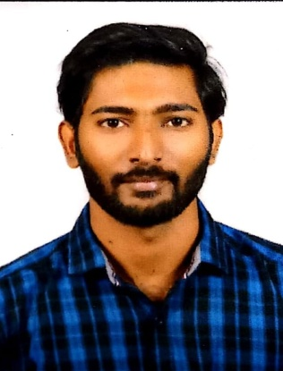
1. Name : Abilash Valluri
2. Designation : Lecturer
3. Date of Birth : 06/08/1993
4. Educational Qualifications : M.A., BEd.,
5. Teaching experience :2 years 2 months
6. Research Experience :Nil
7. Dissertation/thesis Title :Nil
8. No. of Research publications :Nil
9. No. of Books published :Nil
10. No. of Major Minor Research Projects :Nil
11. Title of Minor Research Project Real-Time :Nill
12. No. of International conferences attended :Nill
13. No. of national Conferences attended :Nill
14. No. of papers presented at the seminars/conferences :Nill
15. Refresher courses/Orientation programs Training programs attended :03
16. No of Webinars & Online FDPs attended : 32
17. . Vidwaan Score : Nill
18. Address : 5-3, Yeditha, Mandapeta Mandal, E.G.Dt., A.P. 533234
19. Email : abilashvalluri140@gmail.com
20. Contact No : 9014115171

