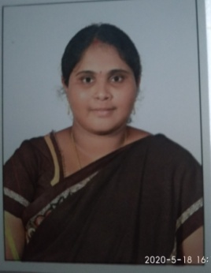
Faculty Profile
- Name : P.BHAGYA SRI
- Designation :ASST.PROFESSOR
- Date of Birth : 13-04-1993
- Educational qualifications : M.SC(MATHS)
- Teaching experience : 6 YEARS 2 MONTHS
- No. of International conferences attended: 01
- No. of National Conference attended: 09
- No. of papers presented at the seminars/conferences: NIL
- Refresher courses/ Orientation programs/training program/attended: NIL
10. Address: Near ZP High school,
Mallavaram,
Narsapur Mandal,
W.G.Dist.(A.P.)

- E-mail id: bhagyasri.javvadi@gmail.com

- Contact no: 7013672377

