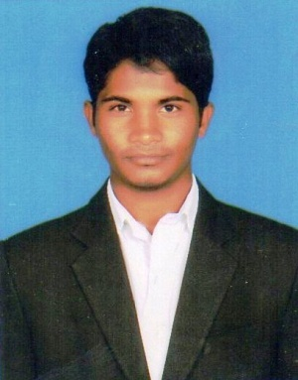
PROFILE

- Name : SHAIK.SADDAM HUSSEN
- Designation : LECTURER
- Department : TOURISM
- Date of Birth : 01-07-1991
- Educational Qualifications : M.B.A (TTM)
- Date of joining : 20-11-2018
- Teaching Experience : 3 years
- Organized Seminars/Conference/work shop: 7 DAY FACULTY DEVELOPMENT PROGRAMME
(DECMBER 10 TO 17TH 2019)
- No. of Workshops/Seminars Attended: 05
10. Address:
SK.SADDAM HUSSEN
LECTURER IN TOURISM
SRI Y.N.COLLEGE (A)
NARASAPUR, 534275
saddamhussenshaik7@gmail.com

