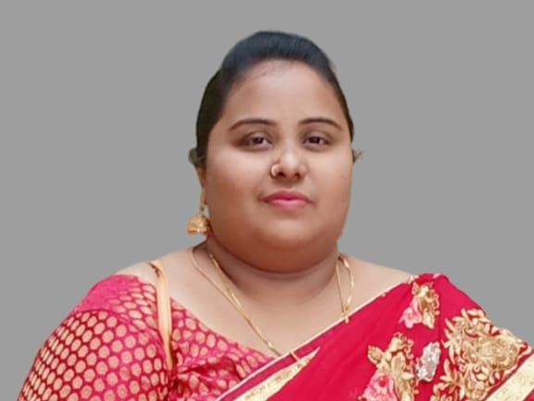
Profile of the Faculty

1. Name : Rehana Begum Mirza
2. Designation : Lecturer
3. Date of Birth : 02/11/1987
4. Educational Qualifications : M.A., CTE.,
5. Teaching experience : 11 years
6. Research Experience : Nil
7. Dissertation/thesis Title : Nil
8. No. of Research publications : Nil
9. No. of Books published : Nil
10. No. of Majo/Minor Research Projects : 01
11. Title of Minor Research Project : “Enriching English Language Communication
Skills Of Under Privileged Students (Rural)
Degree Colleges Of West Godavari Dist.,
Andhra Pradesh”
12. No. of International conferences attended : 02
13. No. of national Conferences attended : 01
14. No. of papers presented at the seminars/conferences : 08
15. Refresher courses/Orientation programs Training programs attended : 02
16. No of Webinars & Online FDPs attended : 30
17. Vidwaan Score : Nil
18. Address : D/O M.Anwar Ali, Darga Center, Narsapur-534275,
West Godavari District, Andhra Pradesh.
19. Email : beautifulrehanamirza@gmail.com
20. Contact No : 9505402861

