Profile of the Faculty
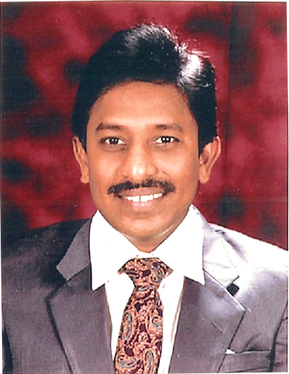
1. Name : Dr. KOPPULA SUSHIL PAUL,
2. Designation : Associate Professor & HoD
3. Date of Birth : 07-04-1965
4. Educational Qualifications : M.A., B.Ed., Ph.D., PGDTE.
5. Teaching experience : 32 Years: PG: 30 Years, UG: 2 Years
6. Research Experience : Nil
7. Dissertation/Thesis Title : Ph.D. Thesis : “The Creative Ways and Means of Characters
Making Their Selves in Toni Morrison’s Fiction”
8. No. of Research publications : 02
9. No. of Books published : 02
10. No. of Major/Minor Research Projects : 00
11. Title of Minor Research Project : --
12. No. of International conferences attended : 10
13. No. of national Conferences attended : 30
14. No. of papers presented at the seminars/conferences : 40
15. Refresher Courses/Orientation Programs Training programs attended : 10

16. No of Webinars & Online FDPs attended : 30
17. Vidwaan Score : Nil
18. Address : H.No.: 13-2/3-28/3, Thomas Bridge Down,
Christian Pet, Narsapur, Pin Code: 534275,
West Godavari District, Andhra Pradesh, India.
.
19. Email : sushilpaulkoppula@gmail.com
s.koppula@rediffmail.com
20. Contact No : 9848098741

