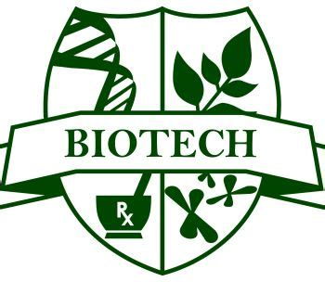
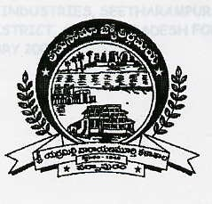
DEPARTMENT OF BIOTECHNOLOGY
SRI YERRAMILLI NARAYANA MURTY COLLEGE (AUTONOMOUS)
Accredited by NAAC with ‘A’ grade with a CGPA of 3.40
Recognized by UGC as ‘College with Potential for Excellence’
NARASAPUR-534275, W.G.Dist. A.P

BOARD OF STUDIES MEETING
2016 – 2021
- Dr. A.Matta Reddy
Department of Zoology
Adikavi Nannya University
9492510010
- Dr. T.Srnivasan
Assistant Prof.
Department of Biotechnology
Gitam University
9440025015
- Sri K.Suresh Babu
Head of the department of Biotechnlology
ABN & PNR College
Kovuru
99668 45824
- Sri T.Ramesh
Head of the department of biotechnology
SVKP & Dr. K.S.Raju Arts & Science College
Penugonda
98667 65259
- Dr.N.Nageswari
Department of Biotechnology
Arts College
Rajahmundry
98662 19559
- Dr.K.Vasudha
Head of the department of Biotechnology
Arts College
Rajahmundry
9704723056, 9701235075
- Dr. K.Rekha
GDC (M)
Srikakulum
9652069674

