SRI G.V.R. INSTITUTE OF EDUCATION –
SRI Y.N. COLLEGE
Narsapur – 534275, W.G.Dt.
Email: ynbedcollege@gmail.com Phone No. : 08814 276768

College Code: 609 / GVRN
Jnanabhumi Code: 19588
AISCHE Code: C-24125

MONTHLY Activities
January, 2023 to December, 2023

ADIKAVI NANNAYA UNIVERSITY,
Rajamahendravaram – 533296, E.G.Dt.

Activities in the month of January, 2023
- New year day means first day of the year 2023 was started with warm greetings from our students, staff and well wishers. Also we greeted our beloved Secretary & Correspondent Dr. C. Satyanarayana garu, Correspondent Sri Polisetti RaghuRama Rao and Treasurer Sri P. Rama Rao garu with fruits and bouquets.
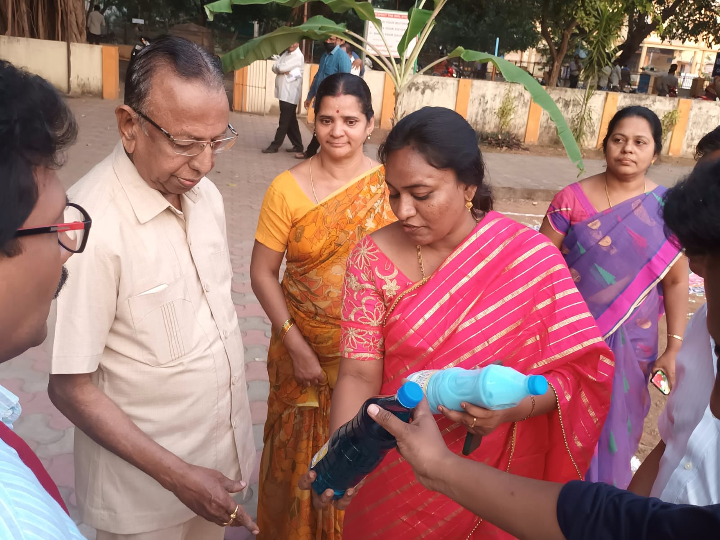
- Some products like Harpic, Phenol, Comfort and Surf-excel were prepared by the B.Ed. Students and also exhibited all those products by arranging stalls during Pongal celebration which was on 10.01.2023.
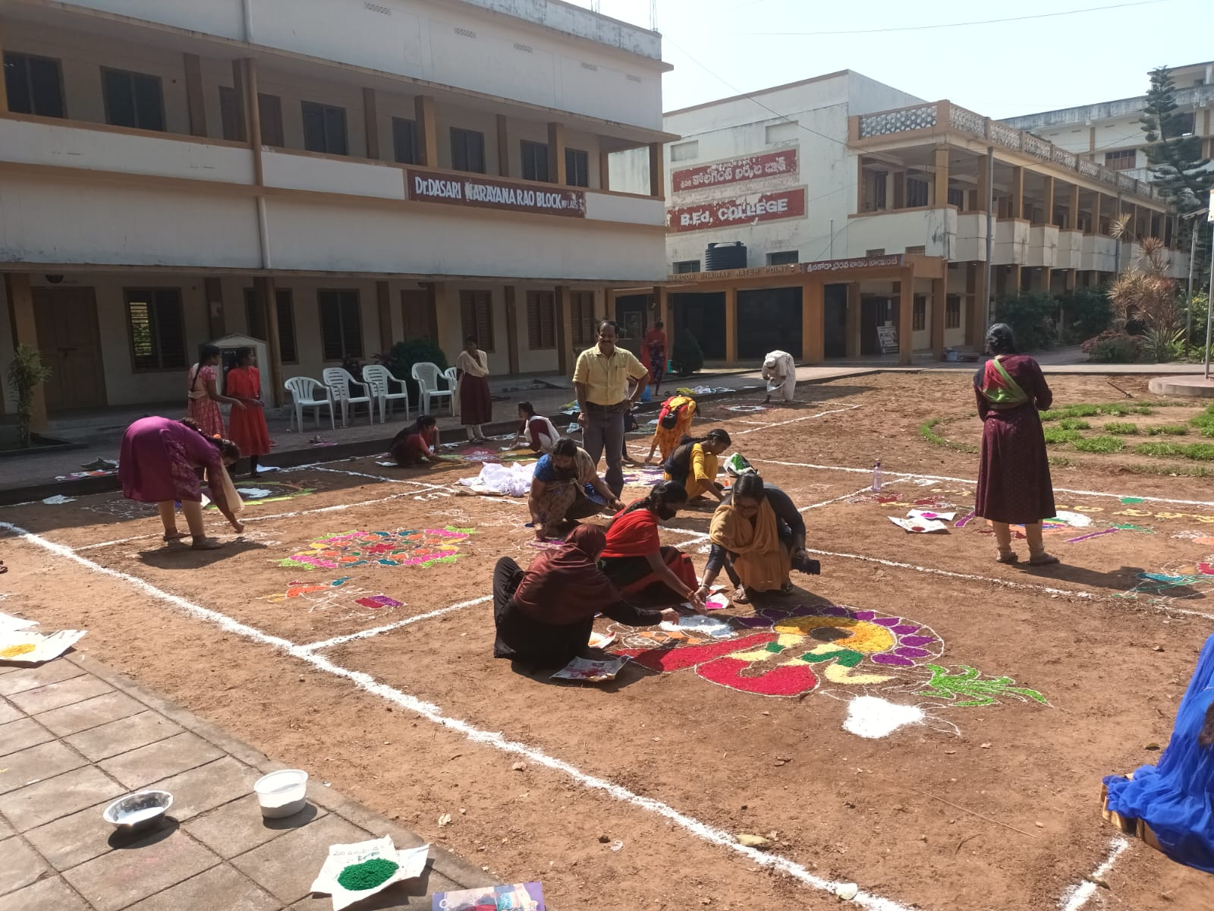
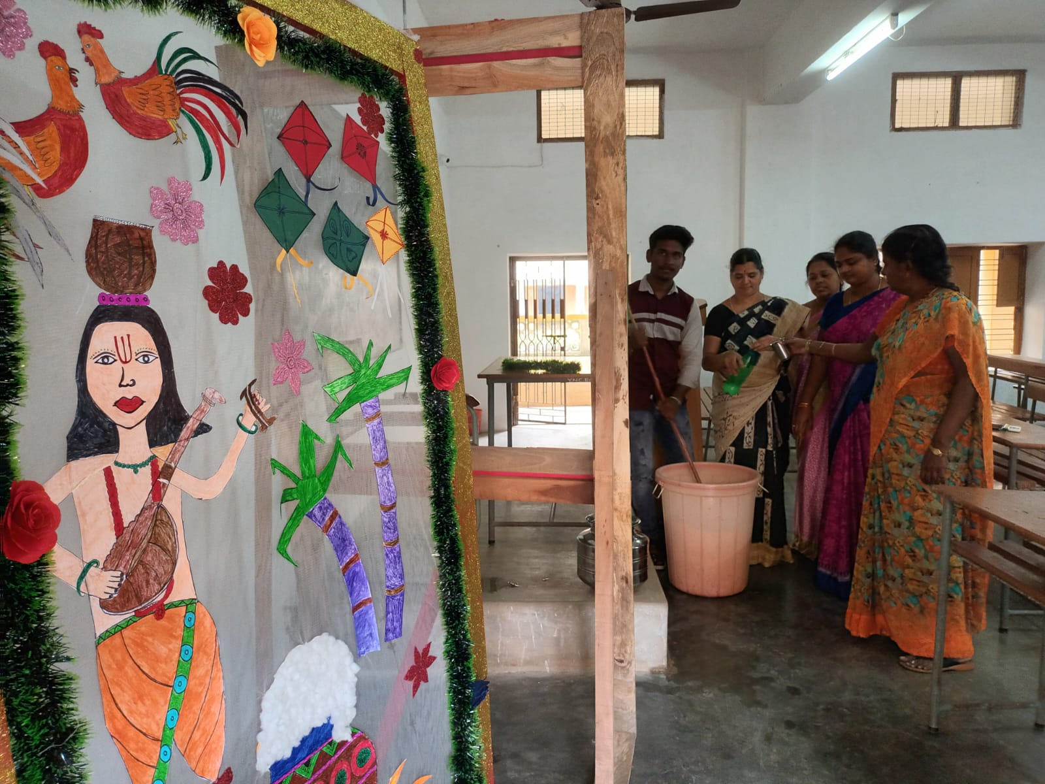
- Pongal celebration was organized in our college campus in which everything was performed as it happens in real way.
- Pongal holidays were given to the college from 13.01.2023 to 18.01.203.
- Seminar was conducted in the college campus on “Skills of effective communication among the students” by well known person Sri ‘Hypno Padmakar’ on 19.01.2023. Students were participated actively.

Activities in the month of February, 2023
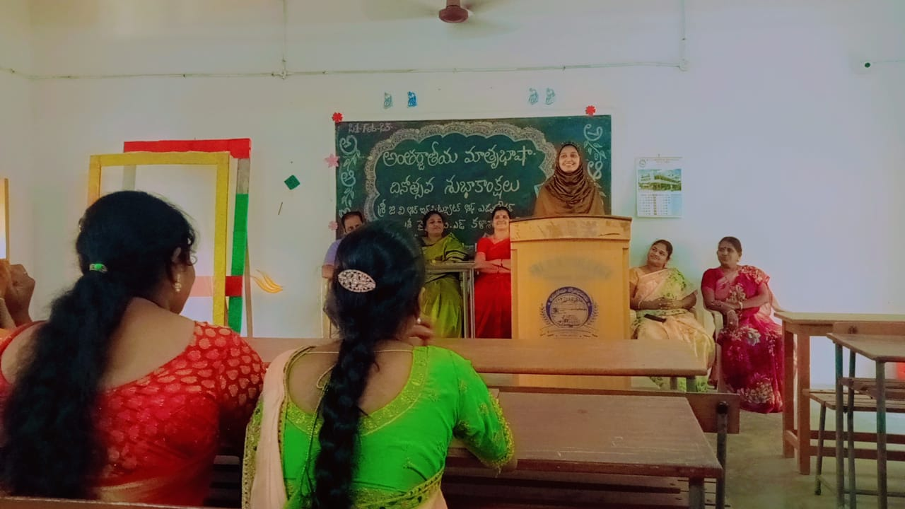
- International Mother tongue day was celebrated on 21.02.2023. Students were participated actively by telling Telugu poems with Rhyme & Rhythm. A competition also conducted among the students.

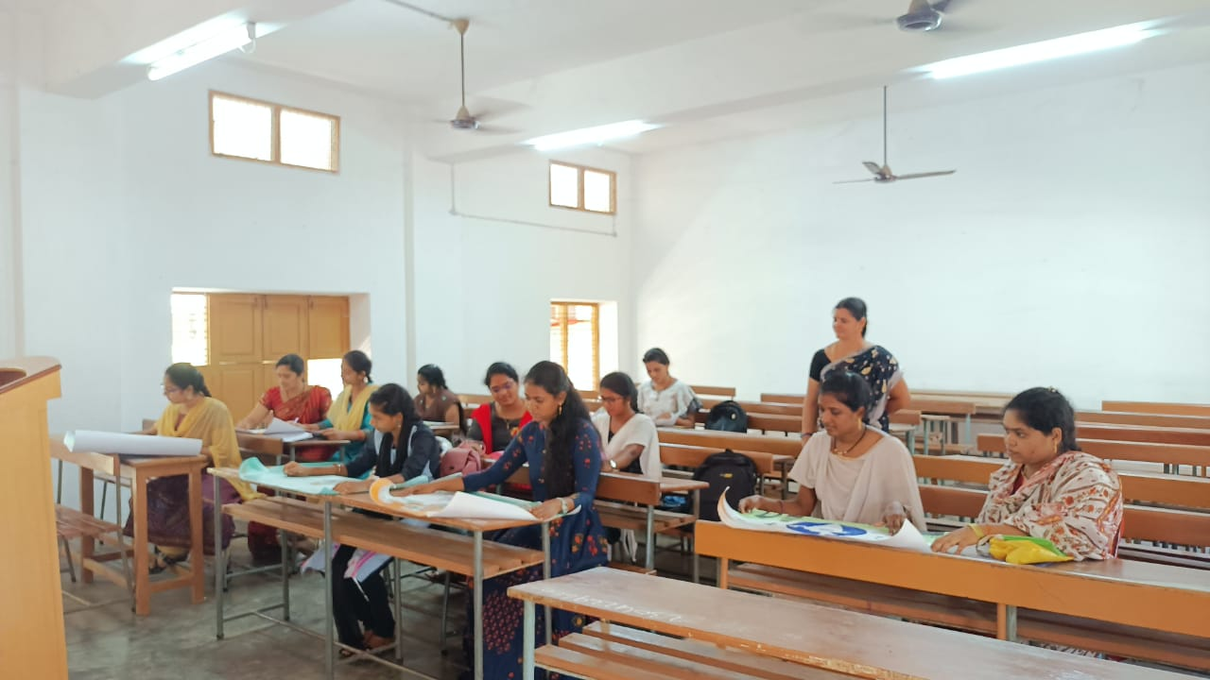
- Mid – II Examination was conducted Semester – III (2021-23 Batch) students on 22.02.2023 & 23.02.2023.
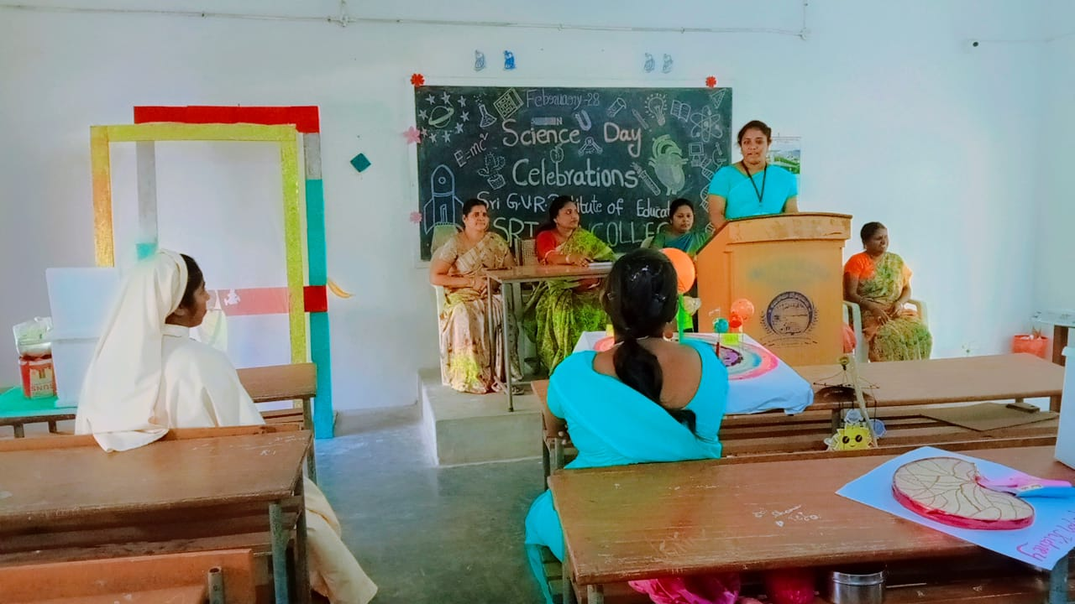

- Science day was celebrated on 28.02.2023 in the college in which Quiz, Essay writing competition were conducted. Students and Staff paid tributes to Dr. C.V. Raman in whose memory today’s Science day was being held.

Activities in the month of March, 2023
- Commencement of the class work for Semester – I students (2022-2023 Batch) in the first week of March i.e. 02.03.2023.
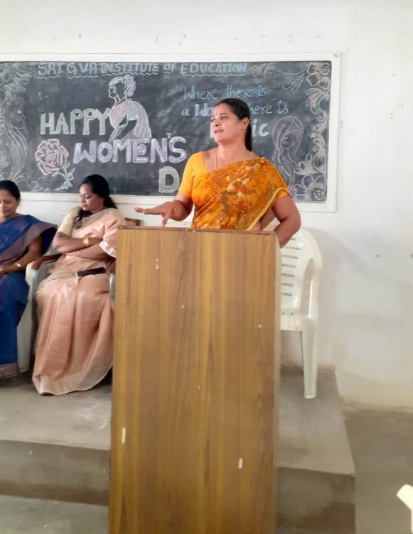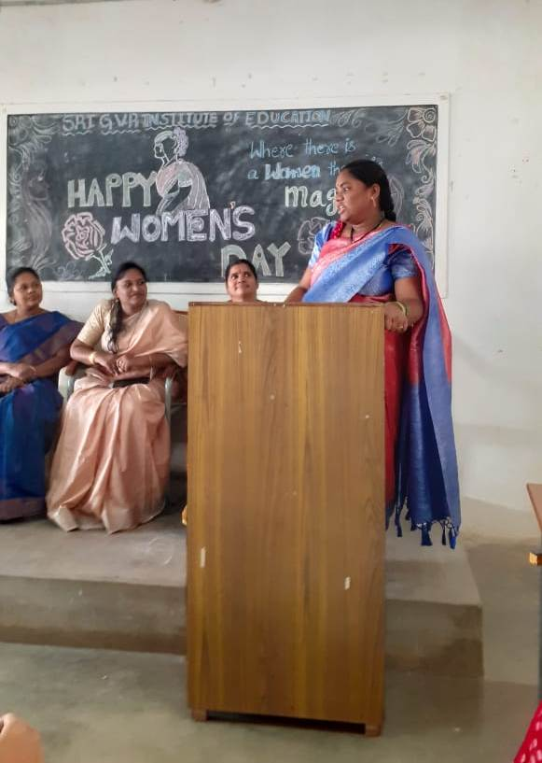

- International Women’s day was observed on 09.03.2023.

Activities in the month of April, 2023
- Ambedkar Jayanthi was celebrated on 14.04.2023 in the college campus. Students garlanded the statue of Ambedkar.
- Final Examination was conducted for Semester III students for the Academic Year 2021-23 from 01.04.2023 to 08.04.2023 by the University.
- Mid – I Examinations was conducted for Semester – I (A.Y. 2022-24) students from 25.04.2023 to 27.04.2023.

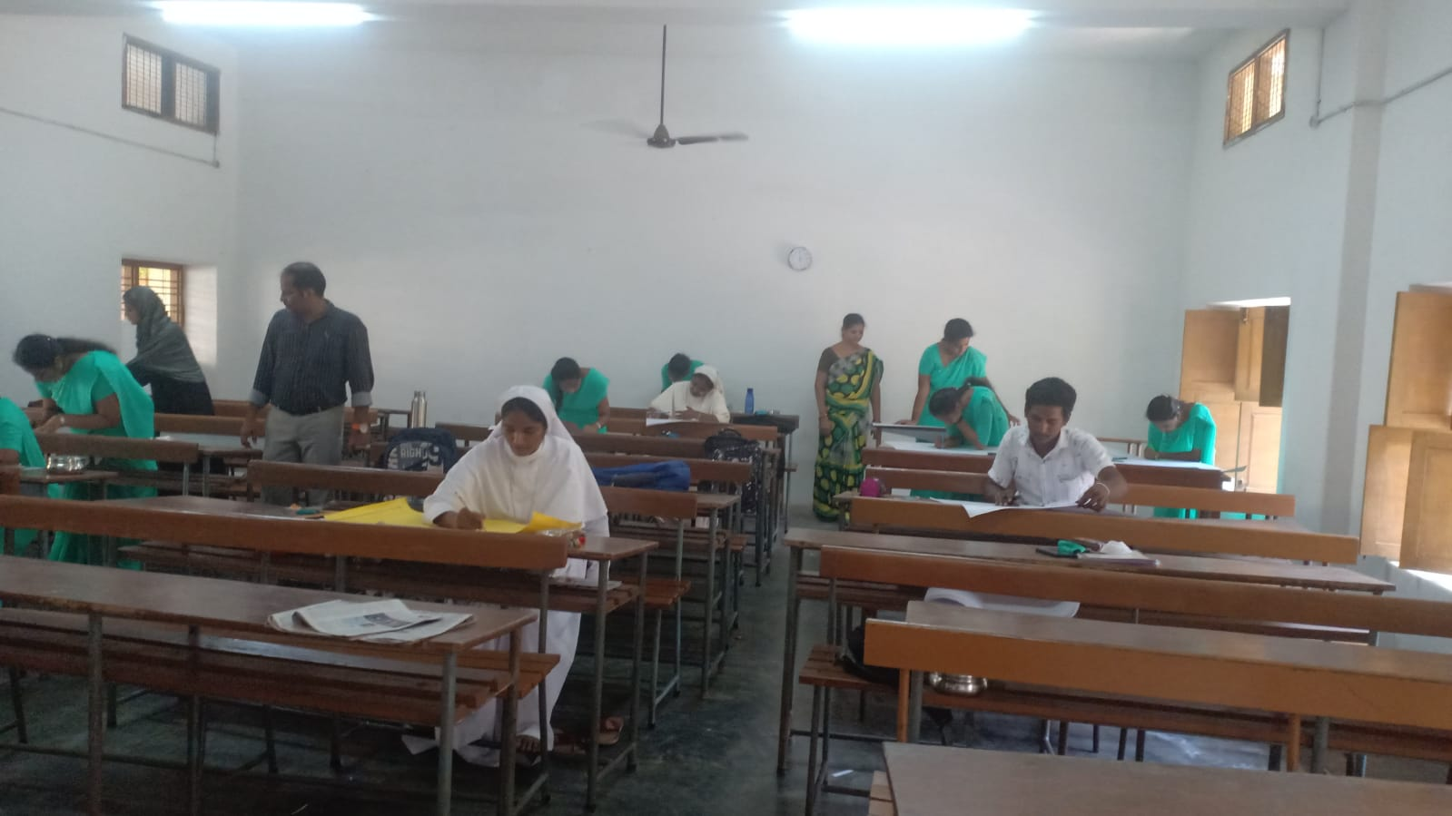
- A Quiz competition was conducted on “Famous rivers, Oceans and other water bodies in our country” among the students by making them into groups on 15.04.2023.

Activities in the month of May, 2023
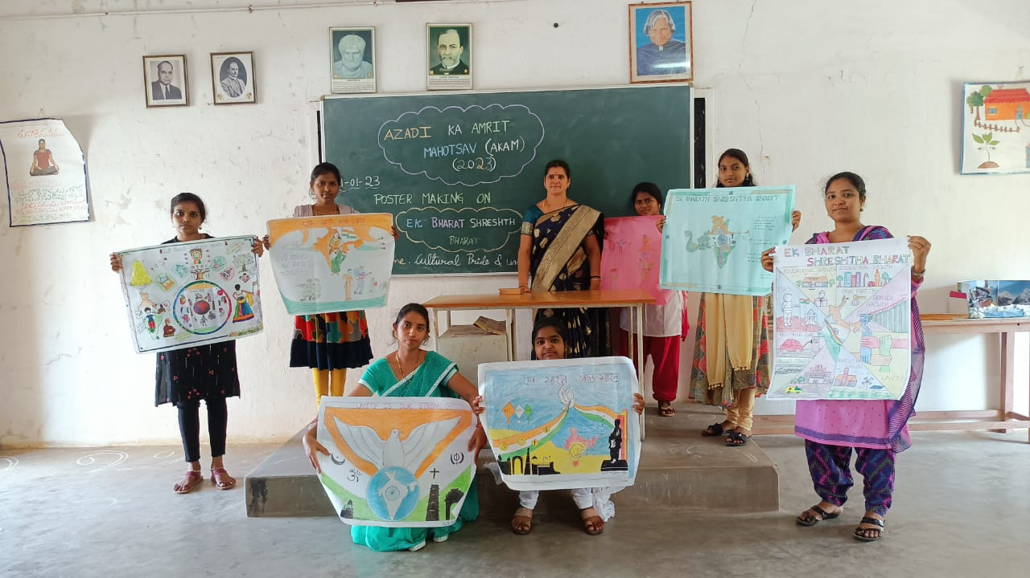
- An Interactive session “Atma Nirbhav Bharat” was conducted among the students on 05.05.2023. Students shared their views one another.
- Moderation Board for Semester – III i.e. Academic Year 2021-23 was conducted by Adikavi Nannaya University on 03.05.2023.

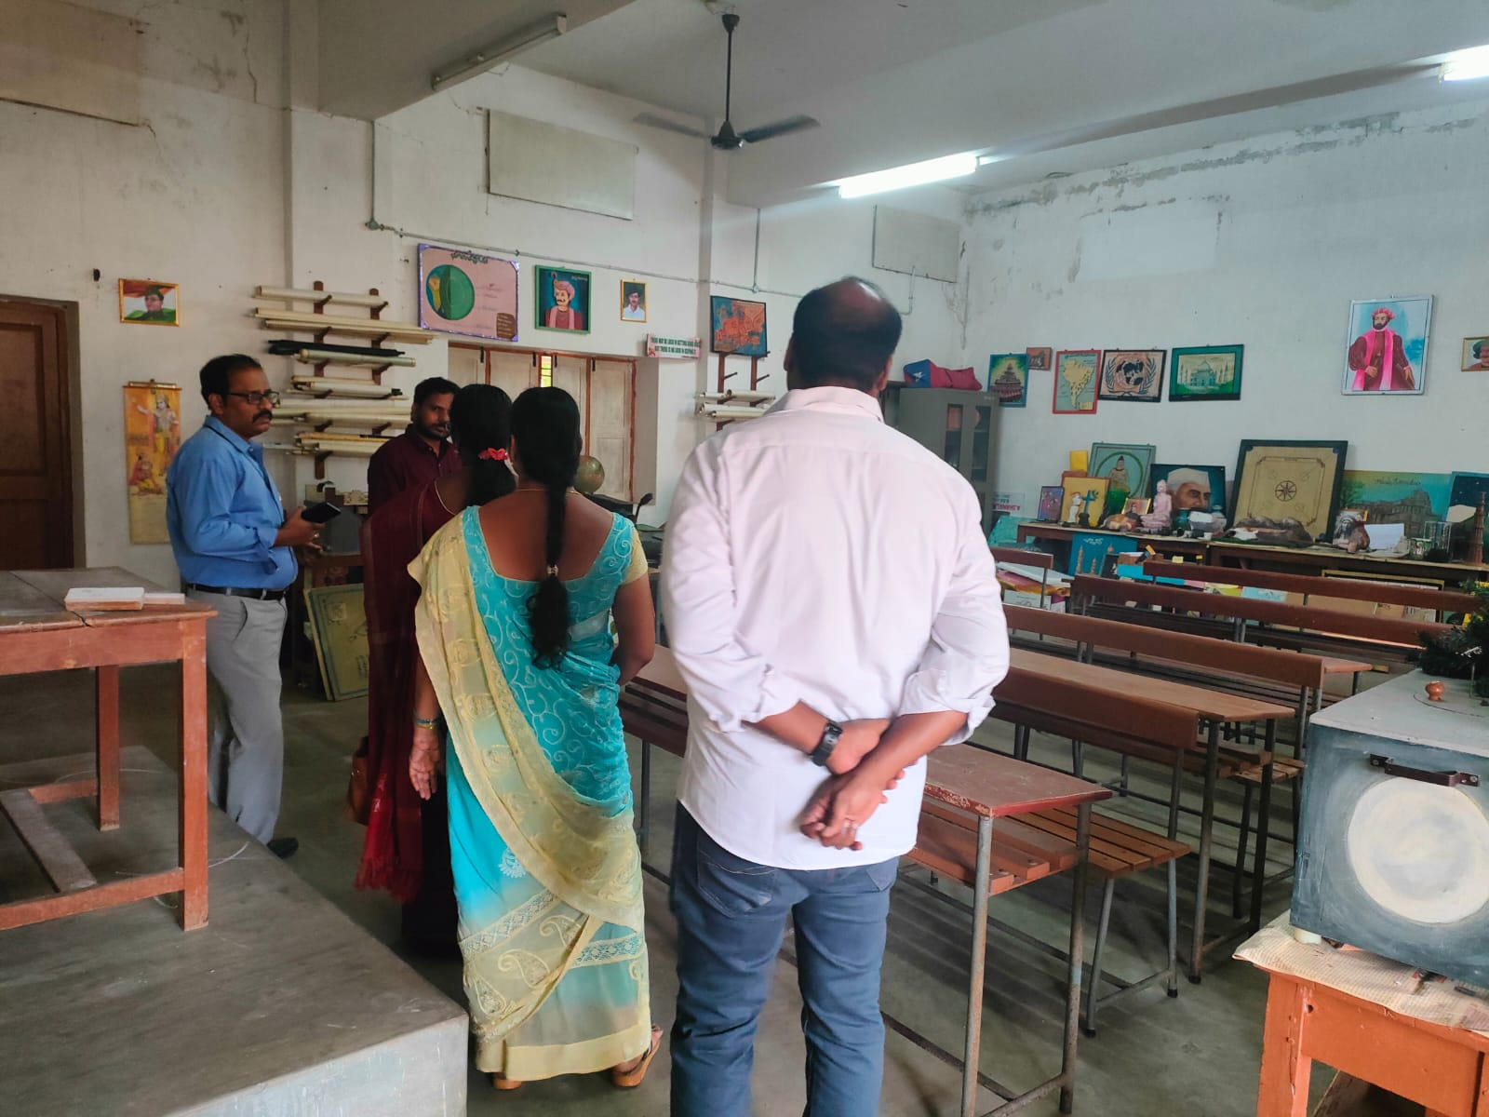
- An inspection was made on IGNOU courses in the college on 31.05.2023. A special team came and observed all the necessary papers and infrastructure.

Activities in the month of June, 2023
- College was re-opened on 14th June, 2023 after summer vacation. Because of heat waves holidays were extended to 14th June, 2023 from 7th June, 2023.
- Mid – I Examinations was conducted for Semester IV (2021-23 A.Y.) students on 16.06.2023 and 17.06.2023.
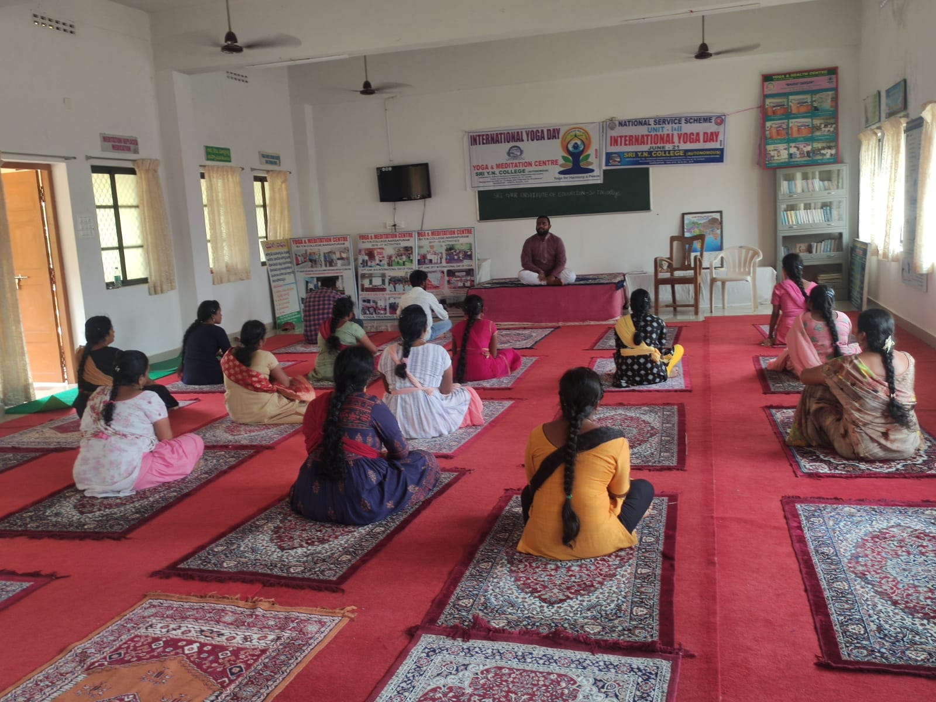
- International Yoga-day was observed on 21.06.2023 in the campus. Self defense techniques also were taught in the class for women students.
- Semester IV i.e. A.Y. 2021-23 students were sent to schools in Narsapur for Teaching-Practice cum Internship training on 18.06.2023 for 20 days.
- Results for Semester III (A.Y. 2021-23) were announced on 14.06.2023 by University. We are very happy to announce that all the students were passed with good grade.

Activities in the month of July, 2023
- Mid – II Examination was conducted for the students of Semester-I and Semester-IV students from 03.07.2023 to 05.07.2023.
- Students of Semester-IV came to college from schools after completion of their teaching practice session on 01.07.2023.

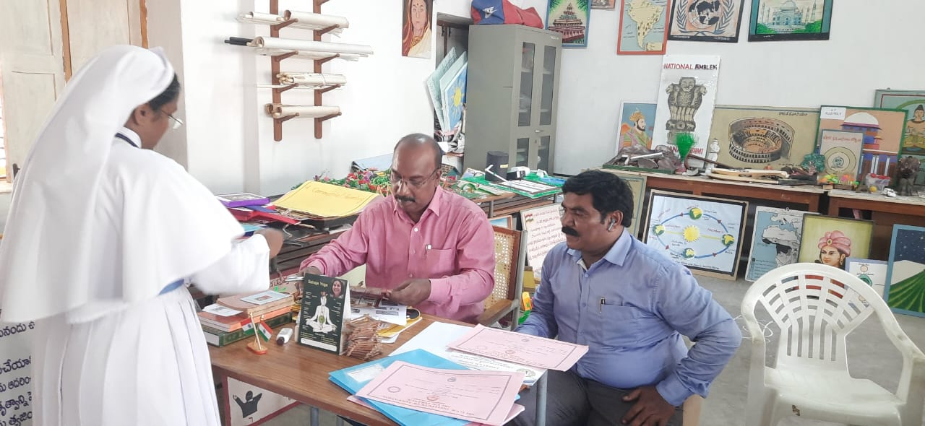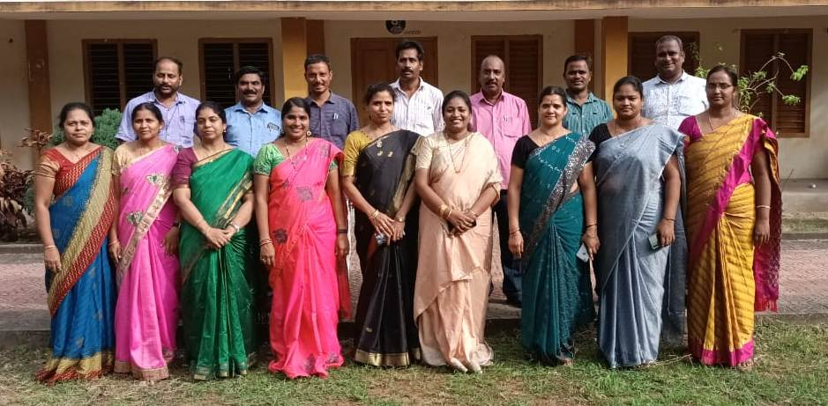
- Practical Examination was conducted for Semester-IV (A.Y. 2021-23) students by the given guidelines of Adikavi Nannaya University on 10.07.2023 and 11.07.2023 with allotted internals and externals.
- AKNU – RJY conducted Examination for Semester – I from 24th July, 2023 to 31.07.2023.

Activities in the month of August, 2023
- 02.08.2023 – University conducted Moderation for Semester – IV of Academic year batch 2021-23.
- 04.08.2023 – Class work started for Semester – II.
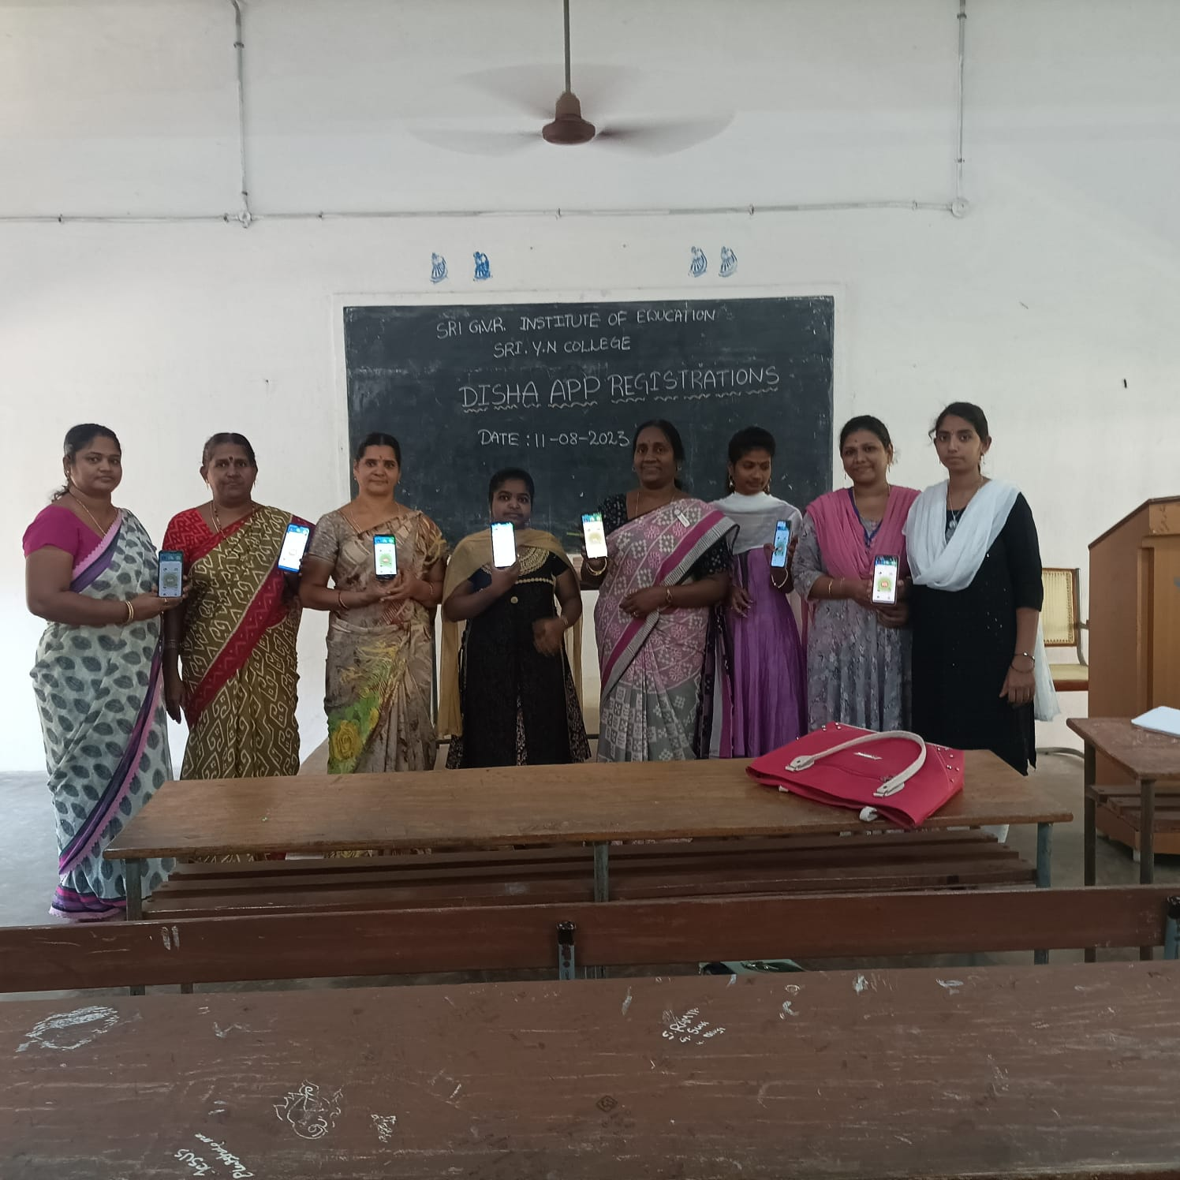
- 11.08.2023 – Mrs. Subba Lakshmi, Women Police came & made the students to download and trust all the app ‘DISHA’ and explained the necessity of that app ‘DISHA’.
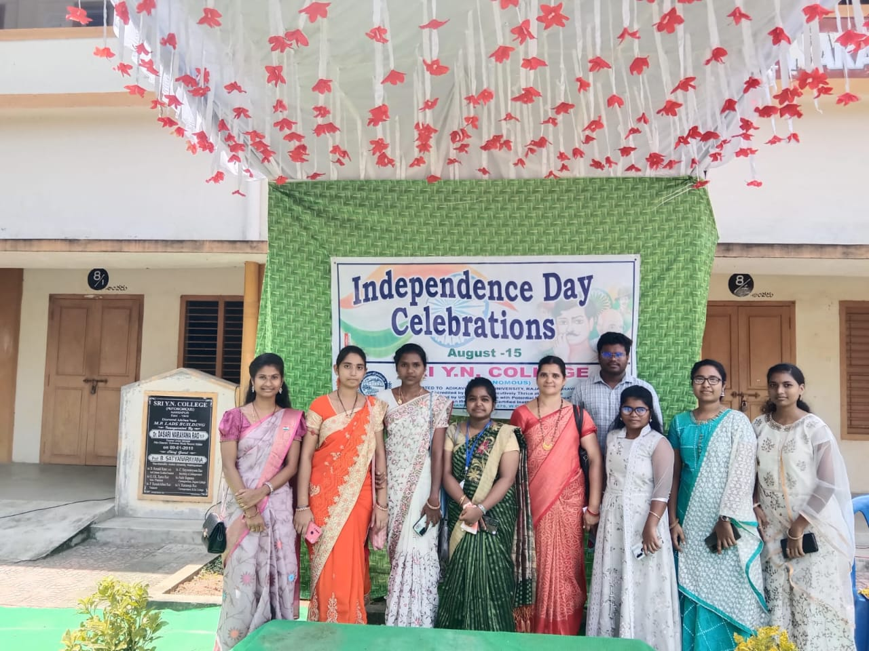
- 15.08.2023 – 77th Independence day celebration were held in our college premises on 15th August. Our students participated in that celebration by giving speech by singing patriotic songs. Students well played their role.
- 21.08.2023 – University conducted Moderation board for Semester – I students of 2022-24 Batch on 21st of this month.
- 29.08.2023 – Matru Bhasha Dinotsvam was observed and celebrated in the college and also conducted a seminar which reveals the importance of Mother tongue.
The National sports day was celebrated on 29th of this month as It is a tribute to the enduring legacy of Major “Dhyan Chand”. All students were enjoyed a lot by playing various games on that day.

Activities in the month of September, 2023
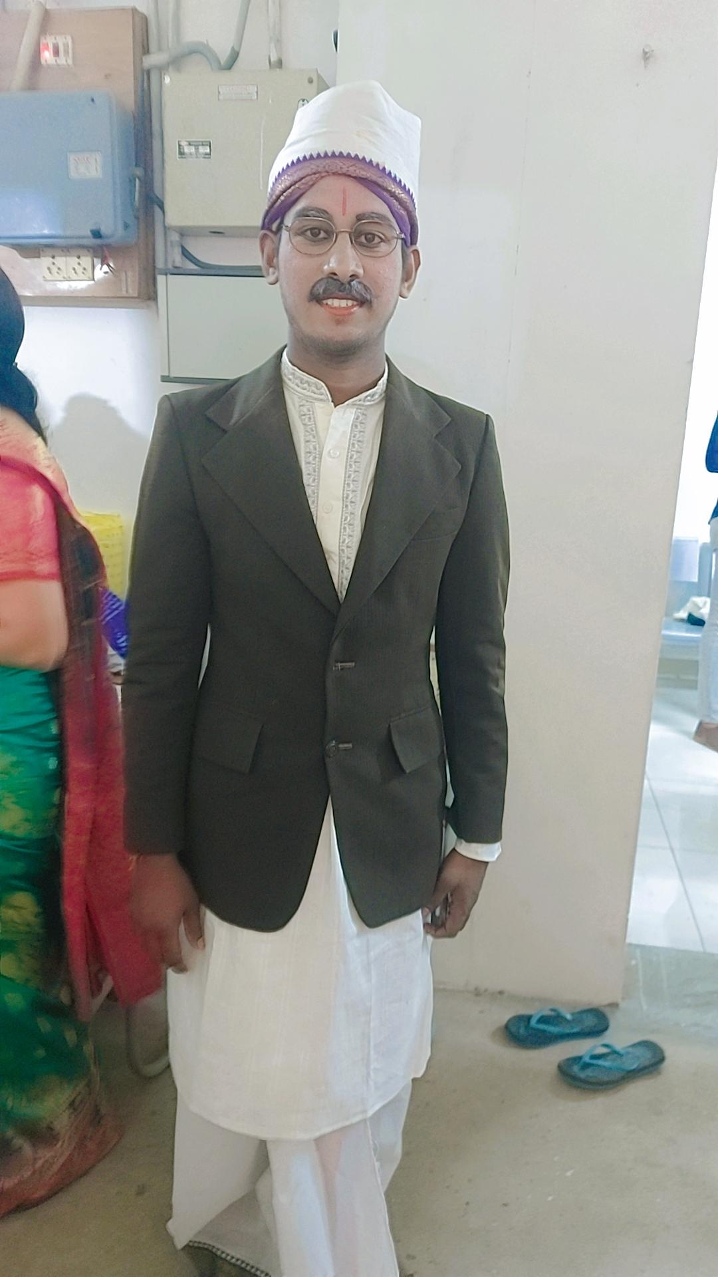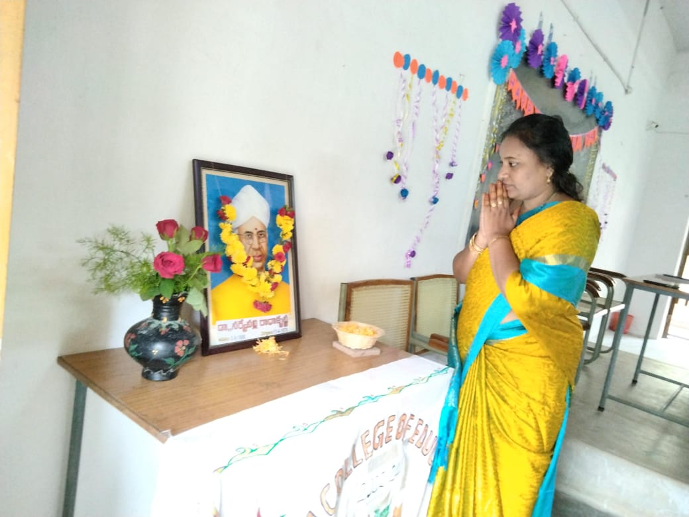
- 05.09.2023 – On the occasion of Teachers day Semester was arranged for the 2nd Semester Students. Dr. Sarvepalli Radha Krishnan photo was garlanded by our faculty & students and all together paid tribute to him.
- Mid – I – Examination was conducted for Semester – II students of 2022-24 Batch from 15.09.2023 to 16.09.2023.
- Students of Semester – II were sent to schools to observe the teachings of different methodologies as it is a part of their training from 25.09.2023 to 30.09.2023.

Activities in the month of October, 2023
- Class work started for the students from 03.10.2023 after they came back from school observation program.
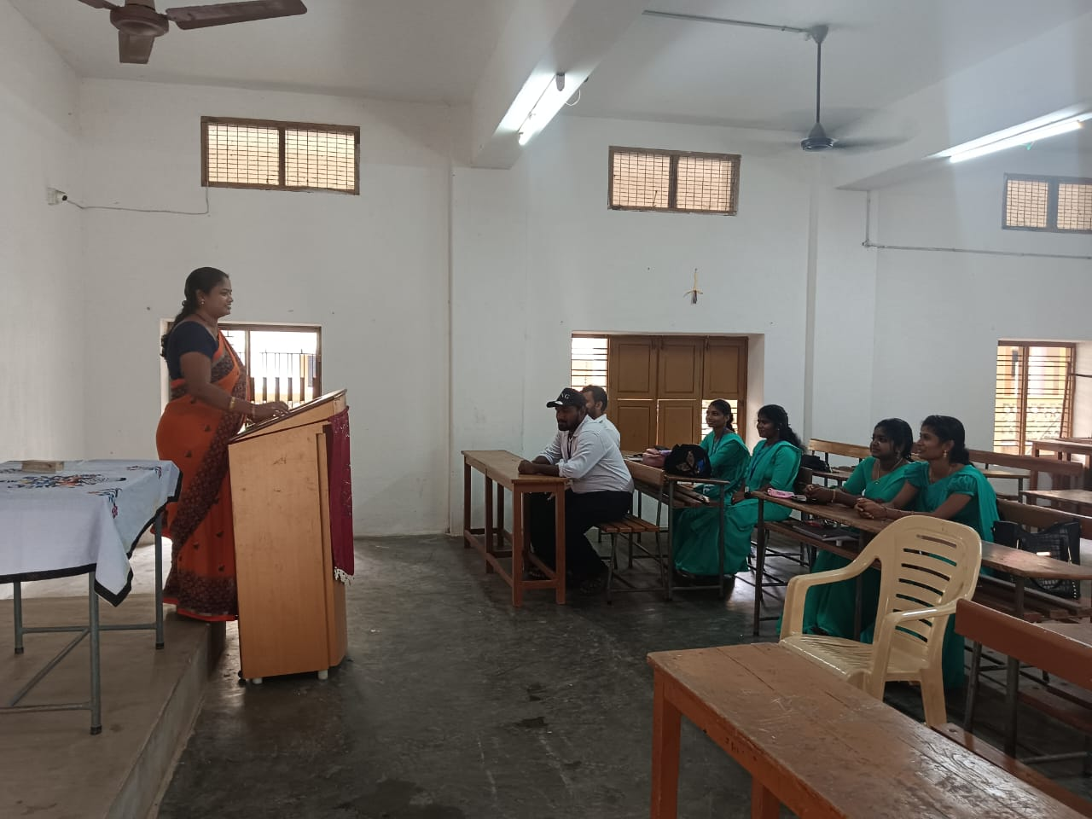
- A work shop was conducted for better understanding of Activity work for which the students already gathered the information from different schools.
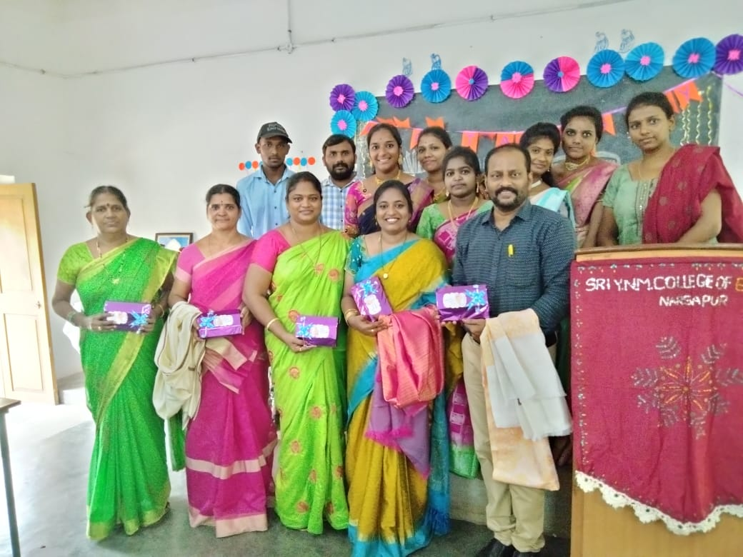
- International teachers day was observed on 5th of this month.
- Dussahra vacation decleared by AKNU – RJY from 19.10.2023 to 25.10.2023.
- College re-opened on 26.10.2023 after Dasra vacation.

Activities in the month of November, 2023
- Mid – II – Examination was conducted for Semester – II of 2022-24 Batch from 03.11.2023 to 04.11.2023.

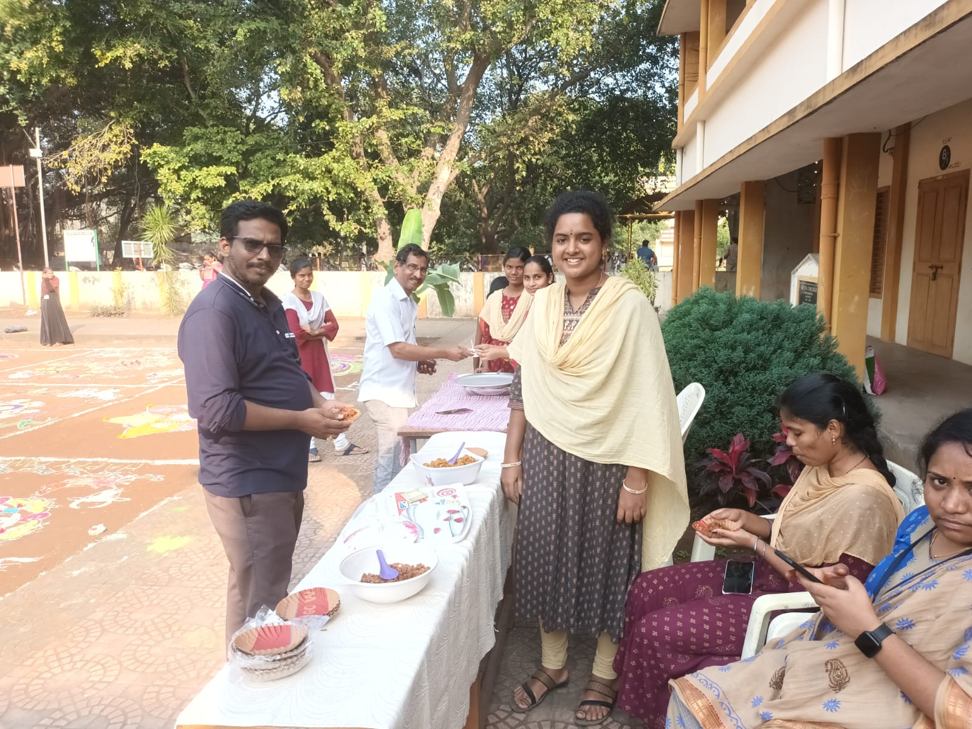
- 14.11.2023 – Children’s day was celebrated in the college in which both Faculty & students – teachers were participated activity.

Activities in the month of December, 2023
- A program was conducted on awareness of Aid on 01.12.2023 as it is Aid’s day.

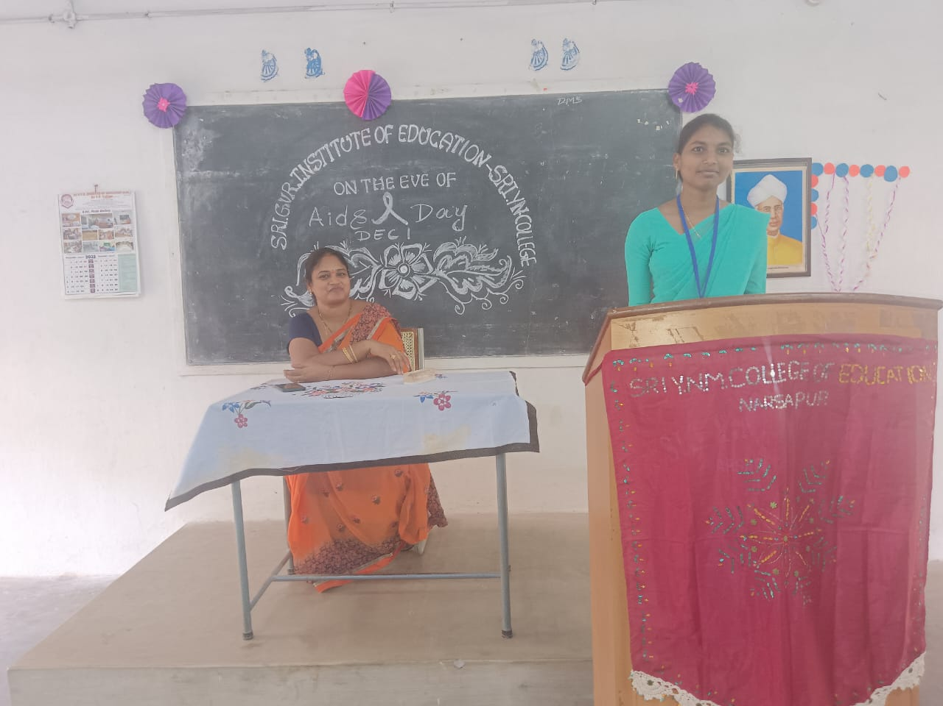
- AKNU-RJY conducted II-Semester Examination from 02.12.2023 to 15.12.2023 due to cyclone effect some Exams were postponed and again conducted in the next schedule given by University.

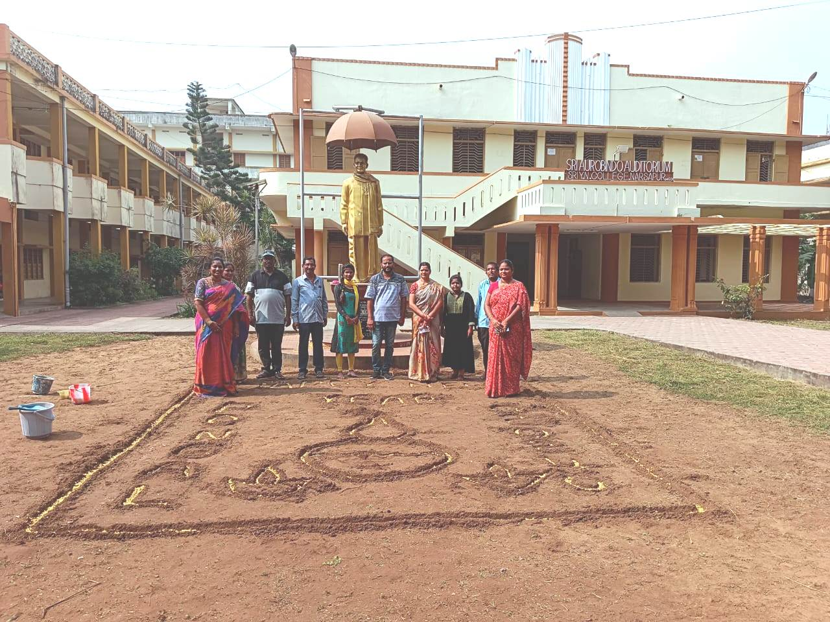
- Students of II- Semester sowed Fenugreek seeds in the form of “Happy New Year & Pongal 2024” on the occasion of New Year 2024.

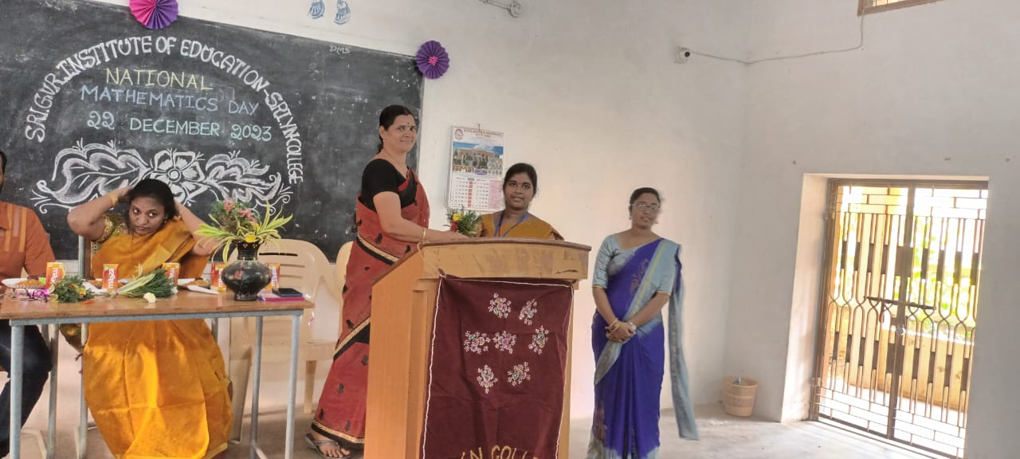
- Math’s day was celebrated on 22.12.2023 on the occasion of one of the greatest mathematicians Sri Srinivasa Ramanujan’s Birthdy. Students have given an useful and excellent speeches on Mathematics.

