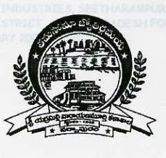
Department of Computer Science (UG)
Sri Y N College
(Autonomous)
(Affiliated to Adikavi Nannaya University)
Accredited by NAAC at ‘A⁺’ grade

NARASAPUR-534275, West Godavari District, Andhra Pradesh
B.China Veeraswamy, M.Sc., 03/07/2025
In-charge HoD

To
The Principal
Sri Y.N.College (A)
Narsapur

Sub: Request stationary for Dept. of Computer Science – regarding.

Respected Sir,

I request you to please provide the following stationary for our dept.

- Attendance registers – 20
- Chalk pieces boxes- 2
- Stapler pins – 2 boxes
- A4 Ream -1
- Office files – 6
- Dusters -8

Thanking you sir

Yours faithfully

(B.CHINA VEERASWAMY)

