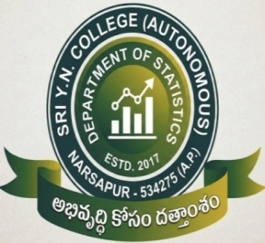

DEPARTMENT OF STATISTICS
SRI Y.N.COLLEGE (AUTONOMOUS)-NARSAPUR
(Affiliated to Adikavi Nannaya University)
Accredited by NAAC at ‘A+’ Grade
Recognized by UGC as ‘College with Potential for Excellence’
2026-2027
[For II, III , IV & V B.Sc students 2020-21 Batch onwards
& for I B.Sc Students w.e.f. 2026-2027 of NEP 2020] _______________________________________________________________________________________________

BOARD OF STUDIES MEETING ON 17-07-2026 AT 3.00 pm
B.Sc Statistics syllabus as prescribed by APSCHE and Adikavi Nannaya University, Rajamahendravaram w.e.f 2026-2027 and ratify the minutes of department meeting held on 17-07-2026 at 3.00pm through online Mode.
Agenda:
- To prepare the syllabi, course-outcomes, programme outcomes, programme specific outcomes and model question papers for the degree I, II & III years for the academic year 2026-27 by making appropriate modifications (above or equal to 20%) to the University Syllabus if necessary.
- To implement the ratio of CIA and SEE 40:60 and the division of marks among the sections in CIA and SEE for the third year degree also from the academic year 2026-27.
- To prepare the syllabi and model question papers for Add-on courses, Certificate courses and Bridge courses for the newly admitted students for the academic year 2026-27.
- To discuss about conducting seminars, workshops, FDP’s in the department for the academic year 2026-27.
- To discuss about conducting guest lecturers, Quiz programmes, field trips, Community service Projects, Internships and student study projects.
- Any other item with permission of the chair.

Members present :
Chairman: Dr. G.S.V.S Sai Baba, HOD
Faculty members:
- Smt. D.Neelima, Lecturer in Statistics 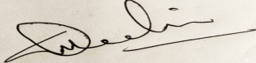

- Sri. P.M.N.Varma, Lecturer in Statistics 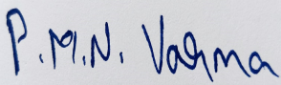

University nominee :
Dr. N.Madhavi, HOD of Statistics,
Government College(A), Rajahmundry. 

Subject Experts :
- Smt. P.Sree devi, Lecturer in Statistics 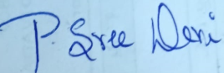
A.N.R. College, Gudivada.

- Dr.A Suhasini, HOD of Statistics
Sri D.M.S.Mahila College, Vijayawada. 
Alumini Members :
Smt. M.Srimayie
Industrialist:
Sri P.S.S.K.Chaitanya Gowd, LDC, 
ICAR-NIRCA (CTRI),Rajahmundry.

Resolutions :

  - It is resolved to adopt and implement new 4 – year UG Honours in B.Sc (Statistics) for I B.Sc Statistics Major & Minor syllabus(w.e.f AY 2026-27), II B.Sc Minor Statistics syllabus (w.e.f AY 2026-27) and III B.Sc. Minor Statistics syllabus (w.e.f AY 2026-27) as prescribed by APSCHE and Adikavi Nannaya University, Rajamahendravaram..
  - It is resolved to approve I, II & III B.Sc., Statistics Major and Minor syllabus(Theory), Model Question paper, Practical Model Question paper for II B.Sc., (w.e.f AY 2026-27) & III B.Sc., (w.e.f. AY 2026-27) as prescribed by the APSCHE and ANUR, by making appropriate modifications to the University syllabus NEP – 2020.
- It is resolved to continue the ratio of CIA and SEE from the present ratio 25:75 to 40:60 from the admitted batch 2023-2024.
- It is resolved to approve the Bridge Course Syllabus for newly admitted Batch for the academic year 2026-2027.
- It is resolved to approve Course Outcomes (CO’s), Programme Outcomes (PO’s) and Programme Specific Outcomes (PSO’s) for the syllabi of degree I, II & III years for the academic year 2026 – 2027.
- a) It is resolved to conduct the Social Immersion Programmme i.e., Short term Internship/Project at the end of the II year degree for the academic year 2026-2027 as per the guidelines given by APSCHE.

b) It is resolved to conduct the Social Immersion Programmme i.e., Semester Internship during VI semester for III year degree students for the academic year 2026-2027 as per the guidelines given by APSCHE.
- Discussed and resolved to conduct a Seminar/workshop.
- It is resolved that the online courses like MOOCS, SWAYAM and courses offered by Spoken tutorial should be done by the Staff and students.
- Discussed regarding the staff publications. It is resolved that the staff members should make good effort to have their publications in the UGC Care List journals, Web of Science and Scopus Indexed Journals.
- It is resolved to make functional MoU’s with various industries and make field visits by sending the students to companies and also invite industry people to the college for giving awareness to the students on various aspects like skill enhancement and job opportunities etc.
- It resolved to evolve a plan of action for the consultancy activity by approaching the business organizations in the district.
- It is resolved to use ICT enabled Tools for effective teaching to the students.
- It is resolved to utilize Media centre for delivering lectures online by the teaching staff members.
- It is resolved to authorize the Chairman, Board of Studies to strengthen the syllabus and model papers of theory and practical examinations keeping in view the latest developments in consultation with other members of the department. Any further guidelines/instructions from APSCHE/ University are to be adopted as communicated.
