Profile of the Faculty
1. Name : Ch.Kalyani Bhargavi
2. Designation : Lecturer in Mathematics
3. Date of Birth : 16-01-1996
4. Education Qualification : M.Sc Mathematics
5. Teaching Experience : 1 year 8 months
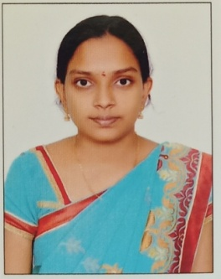
6. Address : D/o Lakshmi Narayana
Near Sunshine School, Royapeta,
Narsapur-534275,
West Godavari District, A.P.
7. E-mail Id : cherukurikalyani11@gmail.com
8. Contact Number : 9110552778

WEBINARS ATTENDED:

1."Role of us in Academic Planning and Education in View of COVID -19 Pandemic and Subsequent Lock-down" on 9th May 2020 by K.G.R.L College.

2.webinar on "Online Teaching Methods Post Covid-19" on 20th May 2020 by
Sri Y.N. college.

3. Online workshop on " RESEARCH METHODOLOGY " Tuning Your Skills in Research Proposals on 28th & 29th of May 2020 by Sri Y.N. college.

