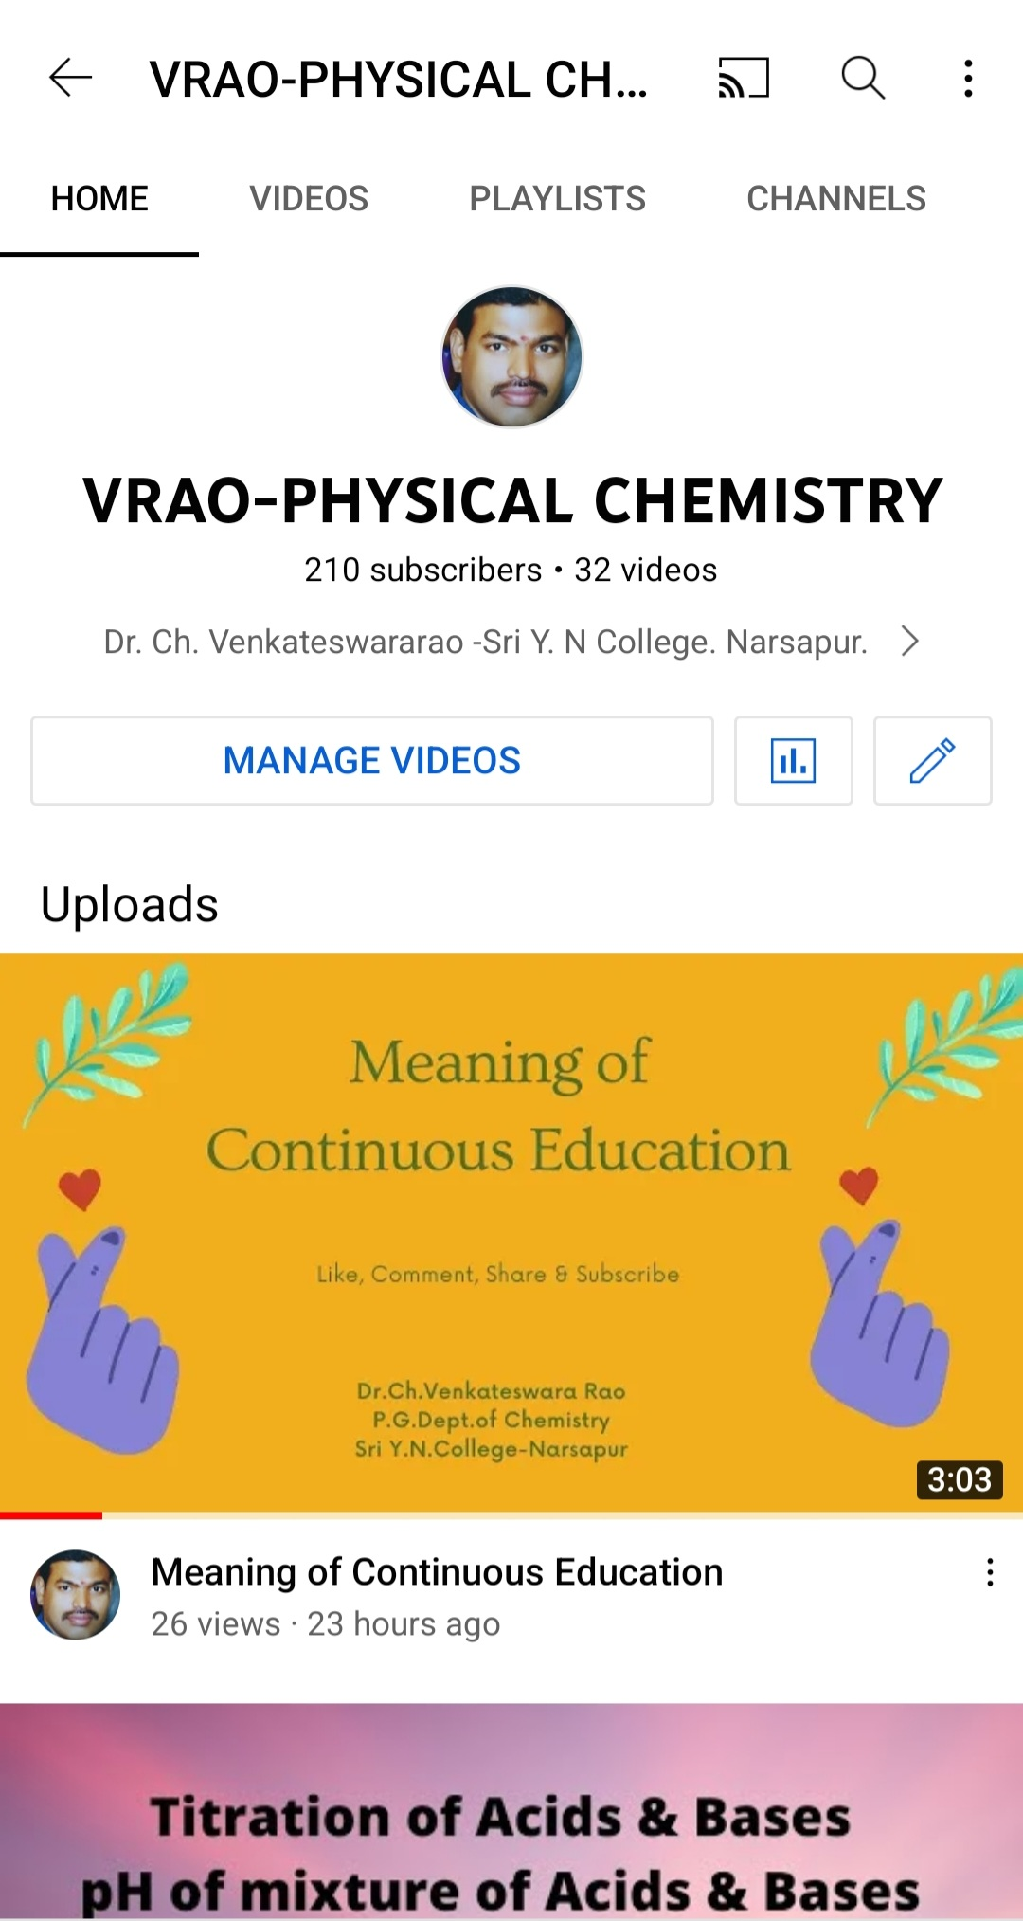

Link
https://youtube.com/channel/UCvMDckmwaBxx94-kkmUn5ZQ

