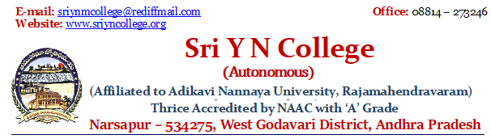

Library is automated using Integrated Library Management System (ILMS).

S. No | Supporting Documents | Reference Link
1. | Policy on Library and its usage | 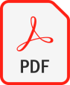
2. | Integrated Library Management System (ILMS)
3. | Library – Infrastructure & Learning resources

