SRI G.V.R. INSTITUTE OF EDUCATION – SRI Y.N. COLLEGE
Narsapur – 534275, W.G.Dt.
Email : ynbedcollege@gmail.com Phone No. : 08814 276768

College Code: 609
Jnanabhumi Code: 19588

MONTHLY Activities
January, 2022 to December, 2022

ADIKAVI NANNAYA UNIVERSITY,
Rajamahendravaram – 533296, E.G.Dt.

Activities in the month of January, 2022
New Year is a joyful festival which is celebrated all over the World. It brings happiness in the lives of many people across the globe irrespective of the caste and culture. As a New Year, the first day of the year you have to start planning and preparations throughout the year. With this motivation and inspiration, our college doing activities in every month according to AKNU norms.
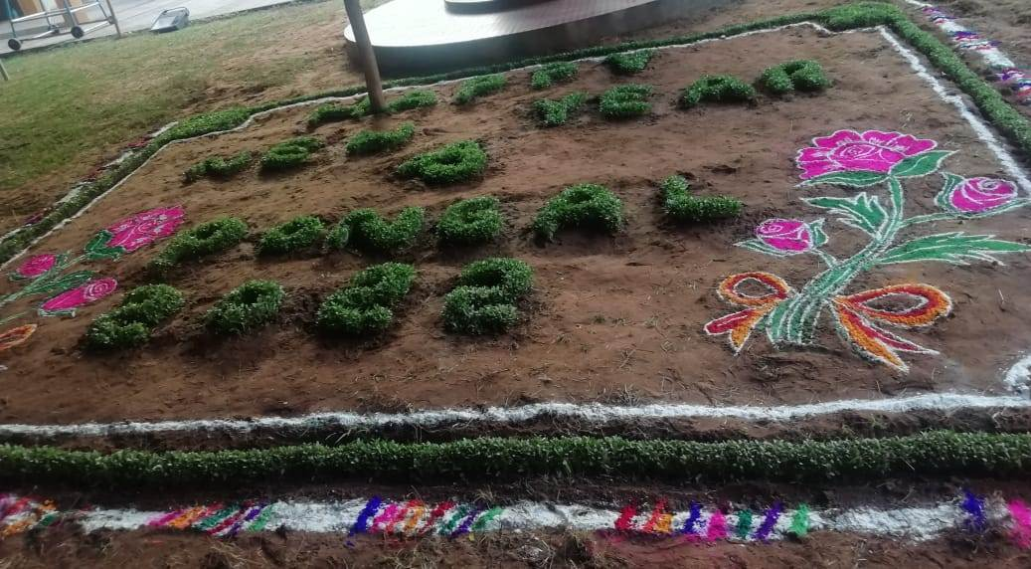
Rangoli resembles life; all you have to do is connect the right dots to make them perfect. To promote this traditional art form among the students, Rangoli making competition was conducted in our college campus on 7th January 2022. The students had to make a Rangoli in a time duration of 1 hour and 30 minutes. The students had pre-planned their patterns and had come prepared with all the materials. The criteria for judgment was the selection of the design, neatness, clarity, colour combination and creativity or new ideas implemented by the students to make their design more presentable.
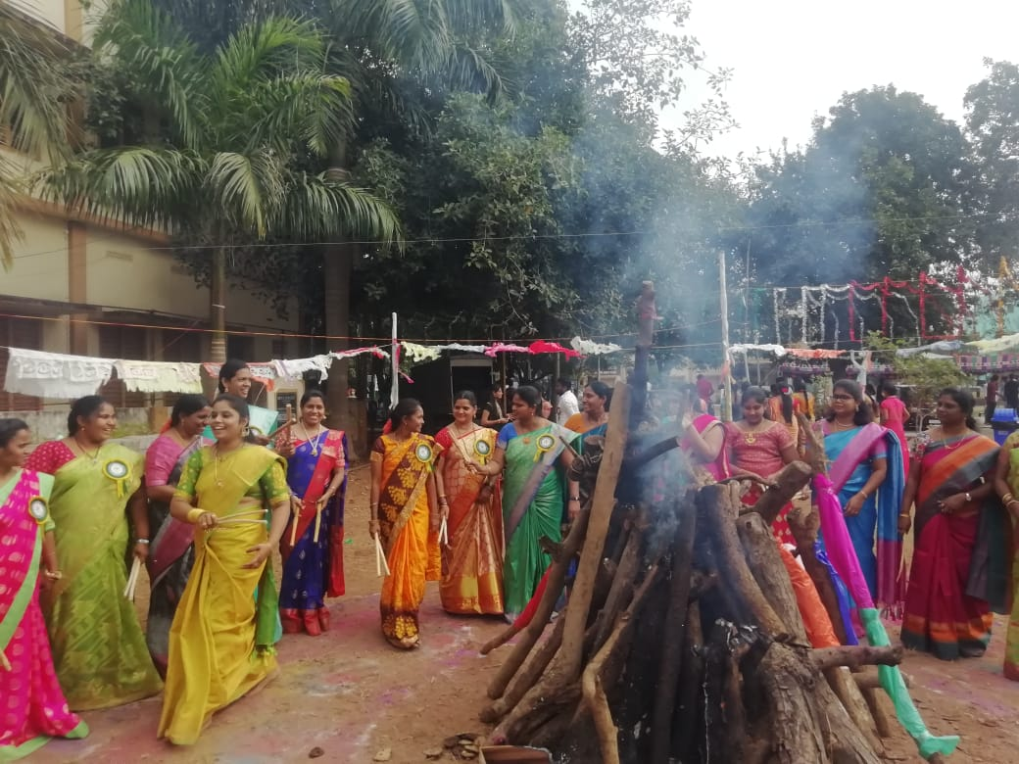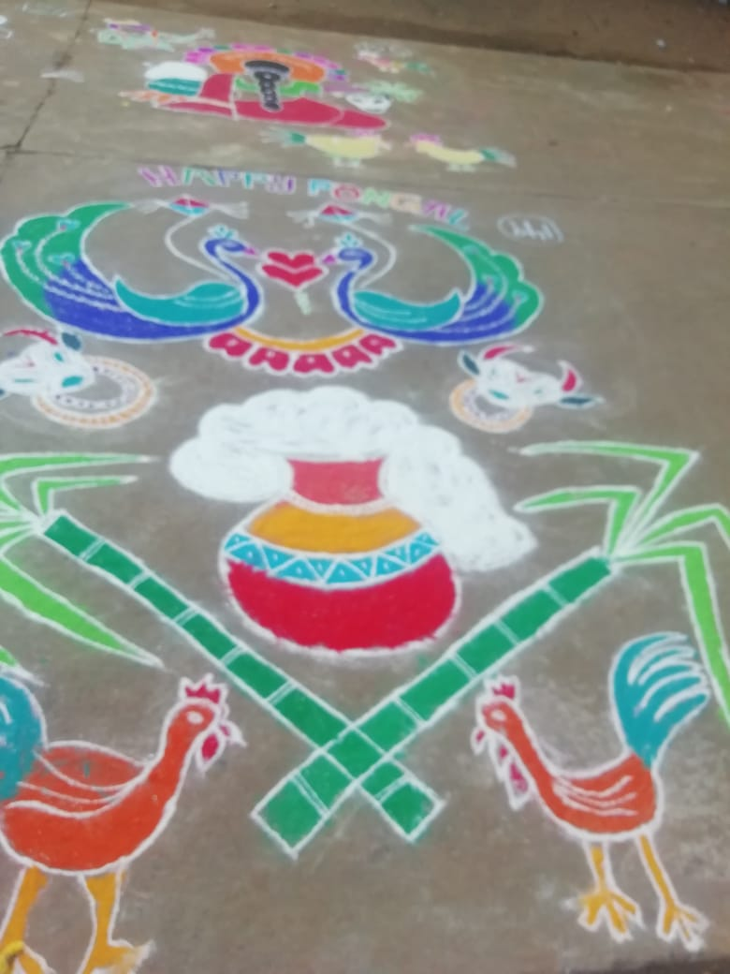
Sankranthi Sambaralu Rangoli
On 8th & 9th January 2022 the Alumni Reunion Celebration was held at Sri Y.N. College, Narsapur, W.G.Dt. The event was stimulating and enjoyable and simultaneously profitable as all members shared their views ideate and good number of new ideas, information and insights came up. Cultural programmes were excellently organized by the students of Sri G.V.R. Institute of Education – Sri Y.N. College (2019-2021 Batch) also participated in cultural programmes especially group dance Krishna leela performed by Rupanjani and Nikhila and solo dance by Nikhila. The Alumni sincerely expressed its gratitude to our college Secretary & Correspondent Dr. C. Satyanarayana Rao garu for his guidance, vision, obsession and instrumental leadership make this event a grand success. It is also a record during the Covid tough time.
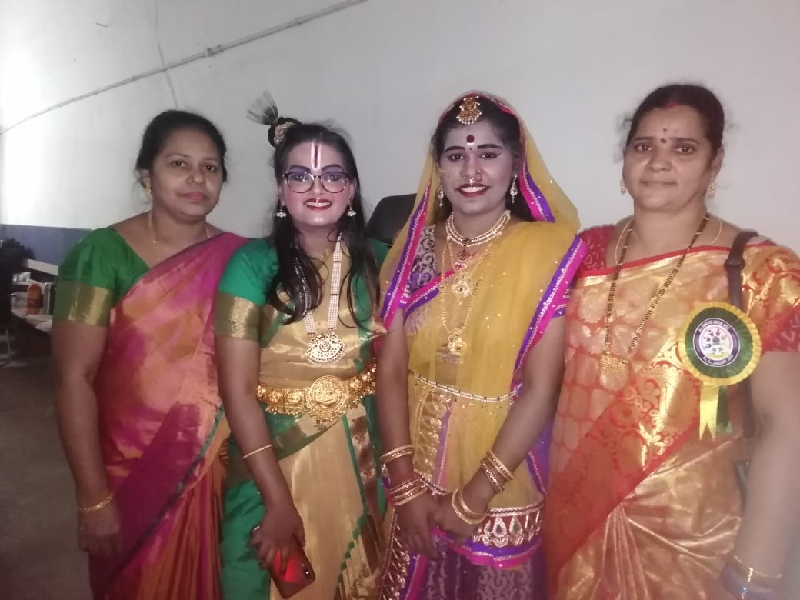
From 12th to 16th Pongal Holidays were declared.
As per the instructions given by the AKNU, on 17th January, 2022 Sanitation is done by the College Campus.
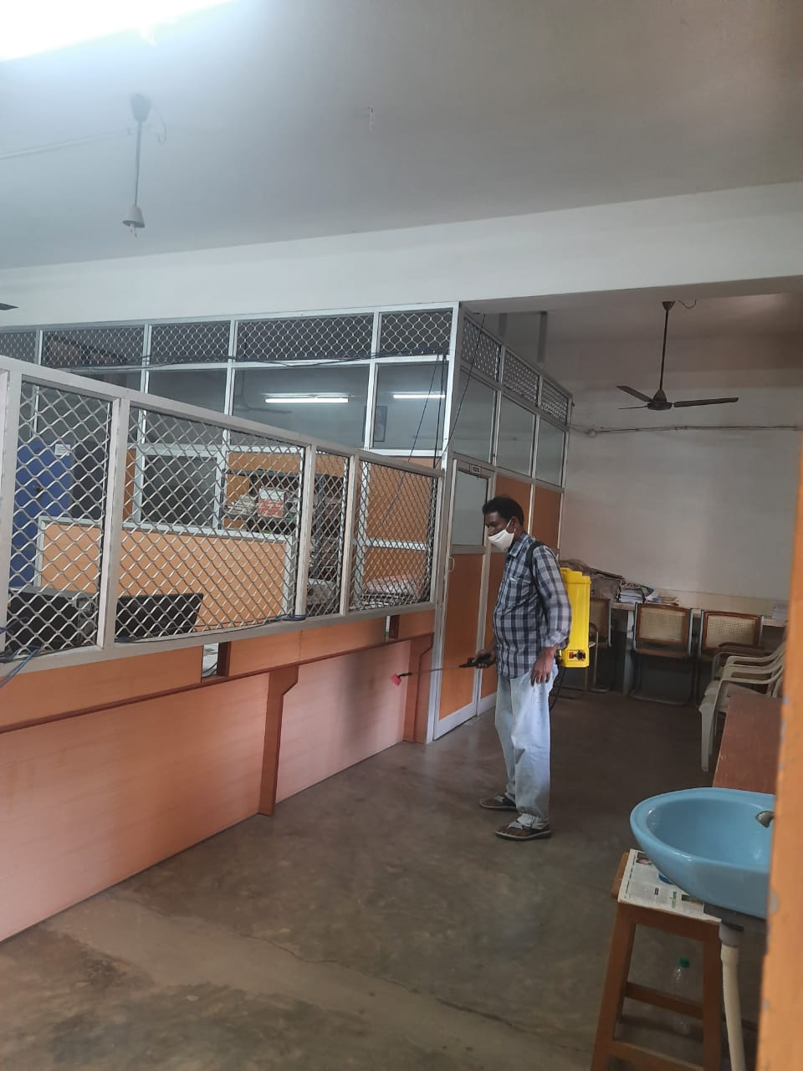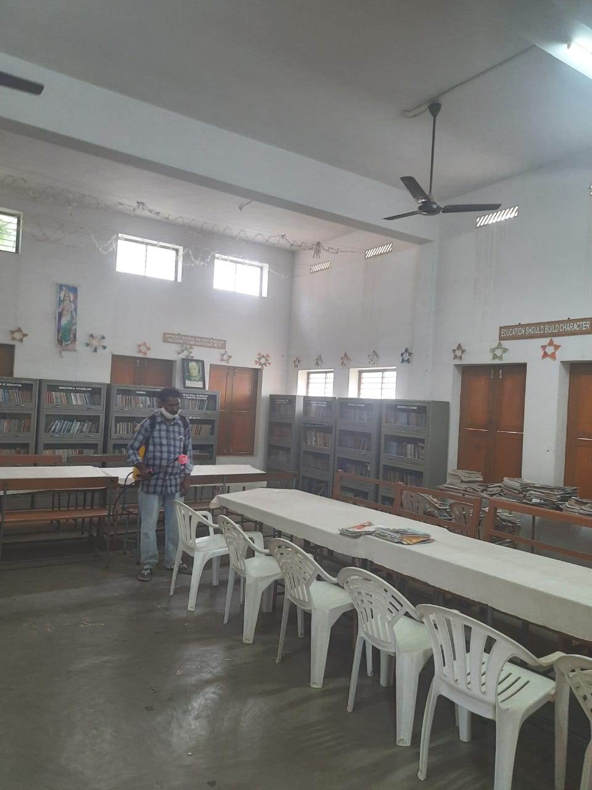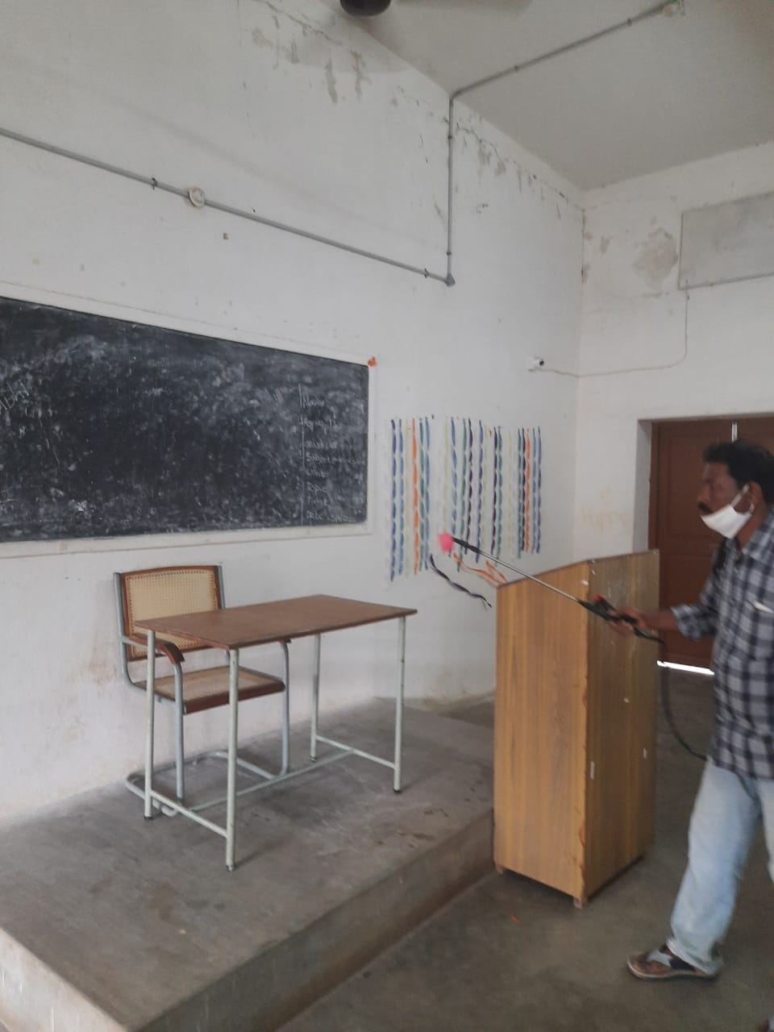
The college has conducted Mid Examinations – I under Semester – III from 21.01.2022 to 22.01.2022 as per the University norms.
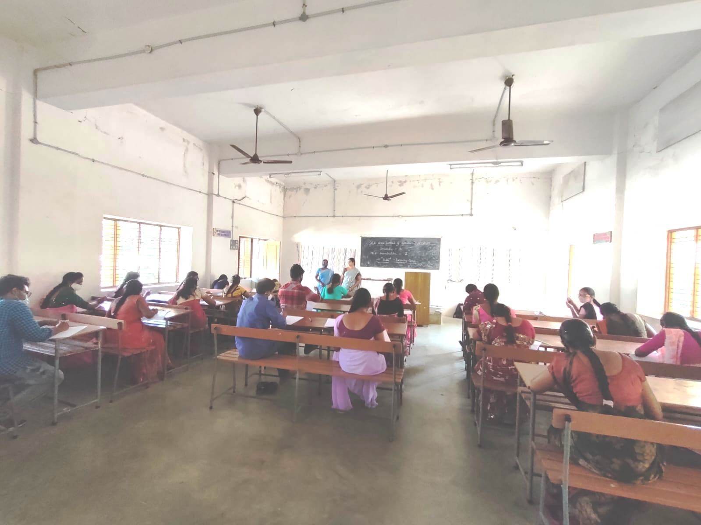
Teaching practice is a key component of the teacher training programme. It is during this period that the student teacher gets to translate the skills and they learnt into reality through actual classroom teaching, and also it provides student teachers with an opportunity to learn from experience in the work place.
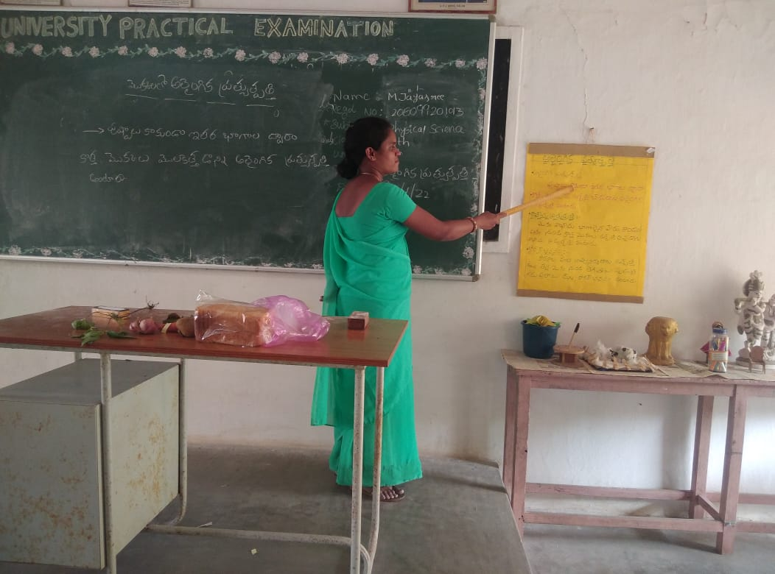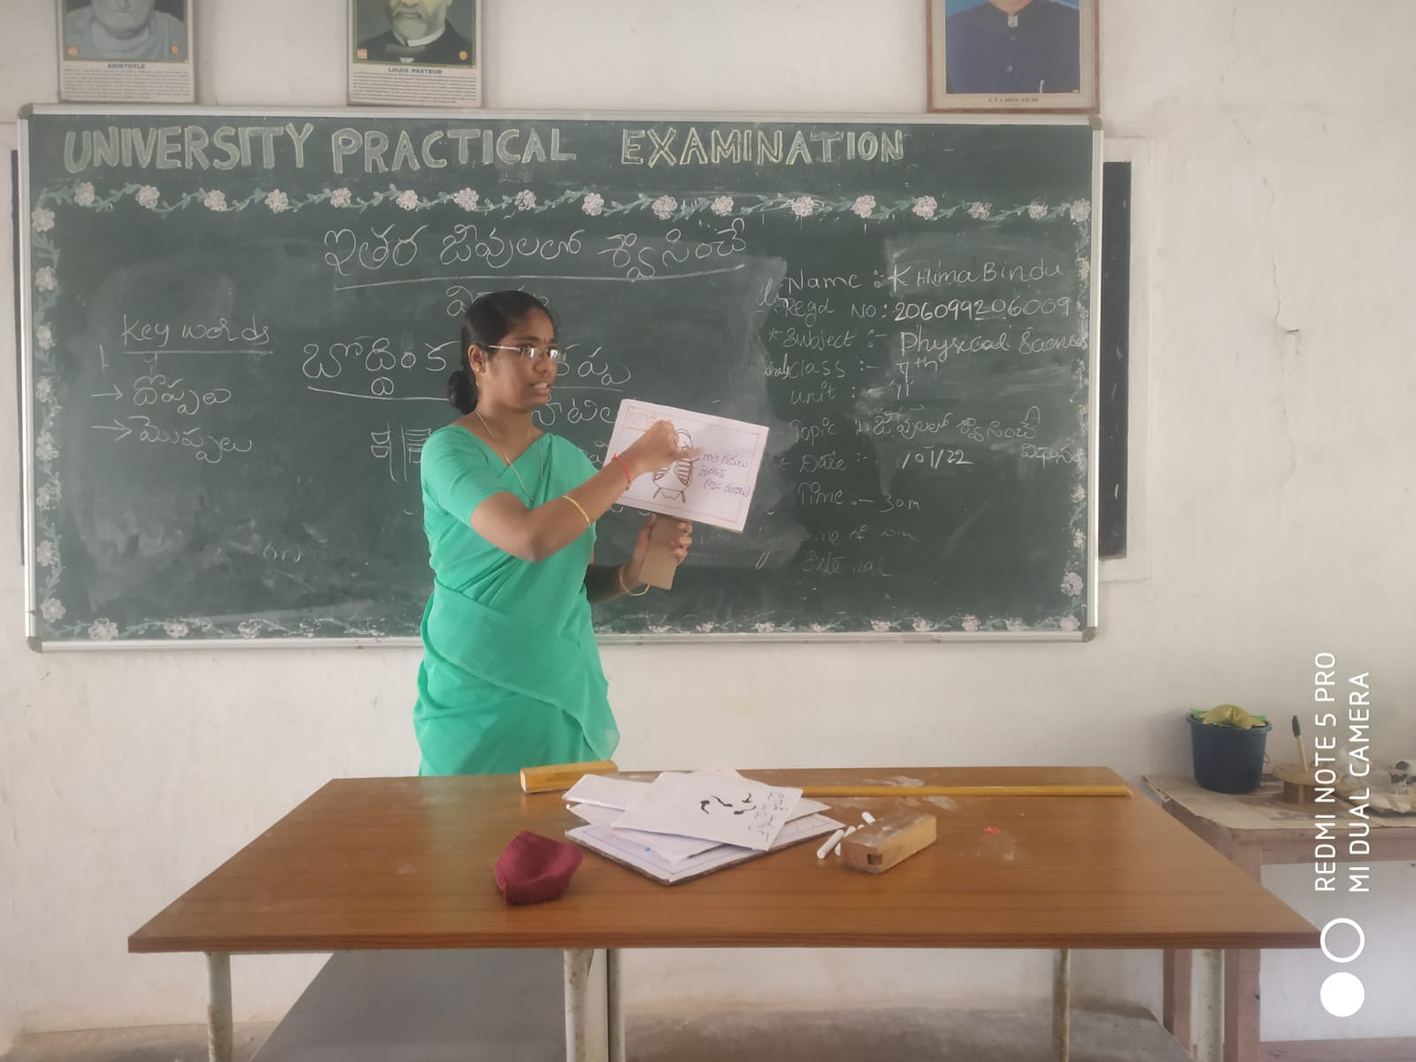
Teaching practice
As the University planned this teaching practice in III Semester in the course, Two macro teaching practice lessons were practiced by student teachers in their respective methodologies on 24th and 25th January 2022, and they were sent for Internship Teaching Practice in different schools in Narsapur mandal from 27th January, 2022.
The month of January unfurled the patriotic feeling to one and all on 26th January, 2022 Sri Y.N. College had organized a grand program on the Occasion of this Republic Day. Everyone was feeling very happy that day because it was a matter of great pride for all of us because on 26th January, 1950 the constitution of India came into force and our country. The college invite Dr. Ande Satish garu as a Chief Guest for this program. He gave a motivational speech to the students which was followed by some speeches on patriotism. Our college students Narayana Sri and Annamani participated in speech. They were very confident and spoke nearly well too. The Management and G.B. members of the college, faculty of the college appreciated both of them.

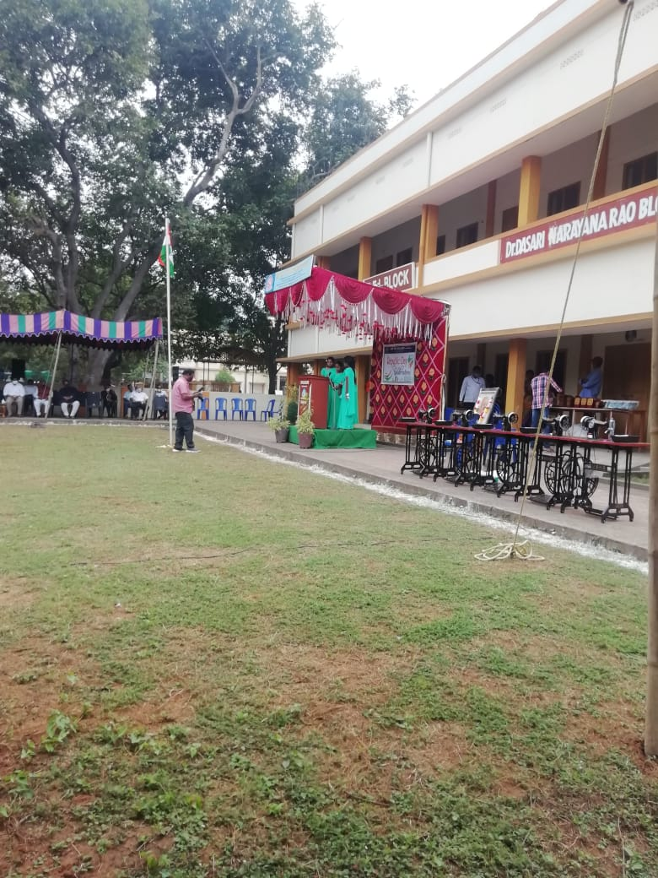
On 27th January, 2022 Ch. R. Devi, Nodal Officer of the college attended online meeting with all Registrars of Universities and Nodal officers on Microsoft up skilling programme
Activities in the month of February, 2022
Education is a shared commitment between dedicated teachers, motivated students and enthusiastic parents with high expectations.
The first instruction meet is a good time to know the students what to expect in terms of the types of activates that they will be doing in the rest of the year.

On 11.02.2022 the college management decided the first commencement day for the batch 2021-23 programme stated with National song Vandematharam. The M.C. for the programme was Mrs. P. Krupaleena Lecturer in English prepared welcome words and invited the staff and new students of 2021-2022 batch and given a glance of Sri Y.N. College facilities and courses which helps to enhance the students education and career.

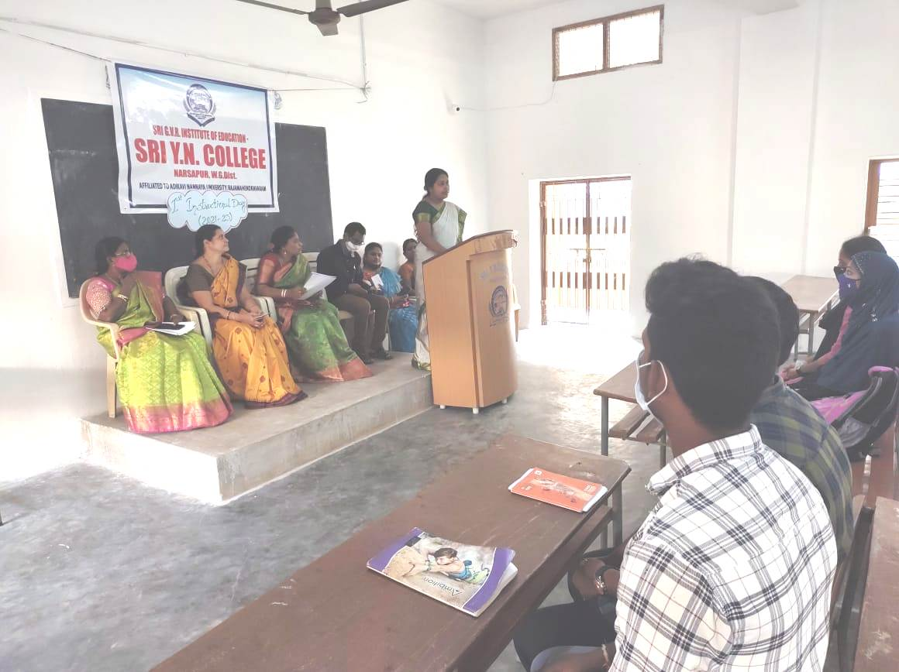

An effective introduction helps to establish a professional set. The M.C. asked the students to introduce themselves and asked to express their opinions towards teaching profession and reason to choose their course. So the students introduced themselves very enthusiastically and expressed their views interests towards teaching profession.
Mrs. G. Radha Lecturer in Education introduced the procedure of assembly timings which is a routine and startup activity of a day of Sri G.V.R. Institute of Education – Sri Y.N. College. Mrs. Ch. Hepsiba Lecturer in Physical Science given instruction about the syllabus curricular frame work of B.Ed. syllabus to get an idea about syllabus.Mrs. Ch. Rudrama Devi Lecturer in Mathematics Methodology given instructions about Record writing work and its importance as the records are mandatory to complete in every semester. Dr. P. Santhi Principal of Sri G.V.R. Institution of Education – Sri Y.N. College concluded the programme by inspiring words.
On Feb 18th The Autobiography of Dr. C. Satyanarayanarao garu ‘The Jeevanayanam’ book was launched by the honourable Rtd. High Court Judge of A.P. Grandhi Bhavani Prasad garu and he shared few words about the Author and the book. Besides all there colour full spectaculars programme, great inspiring and motivational speeches, attendance of famous personalities and great crowd, there was a unexpected inspiring programme performed by falicitated all the members who are behind the screen helped to bring out the ideal autobiography “The Jeevana Yanam”. This act shows his loyalty.

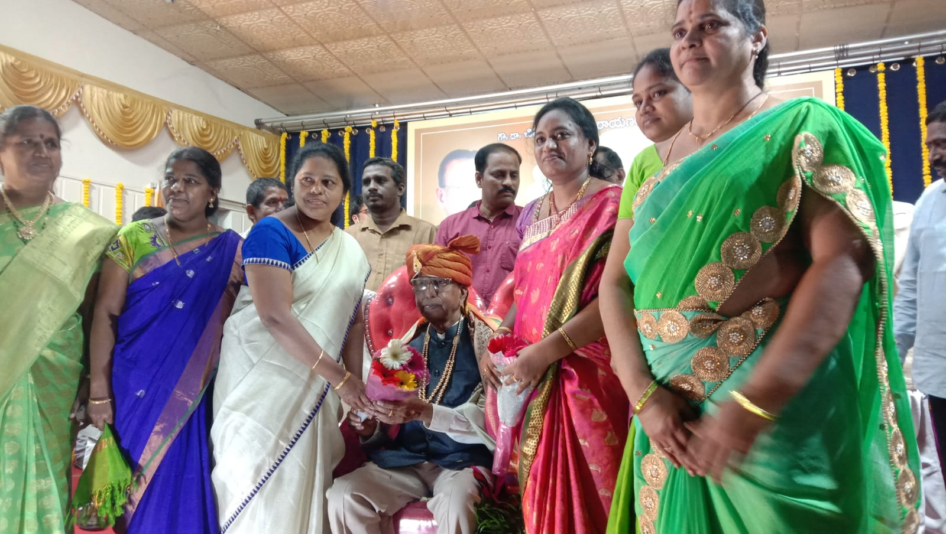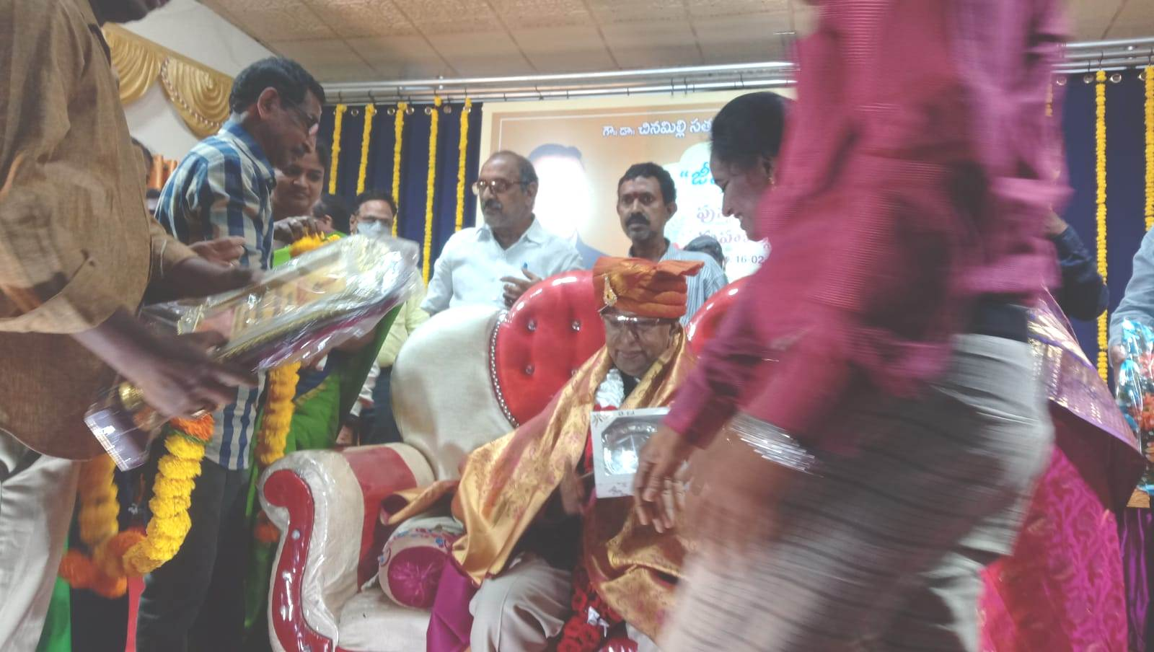
A famous well known personality Cicero words are apt to Sri Dr. C. Satyanarayanarao garu the words are like this “A thankful heart is not only the greatest virtue, but the parent of all other virtues”.
On the grand success of book launching filled the people of Narsapur and staff of Sri Y.N. College with great happiness. People of Narsapur , Staff of Sri Y.N. College and Sri G.V.R. Institute of Education – Sri Y.N. College honored Dr. C. Satyanarayanarao garu with great joy by falicitations, garlanding and presenting mementoes.
On 23rd February, 2022 celebrated “International Mother tongue day” in seminar mode. The first year students participated in this programme and shared their views on impact of Mother tongue in the present Scenario.
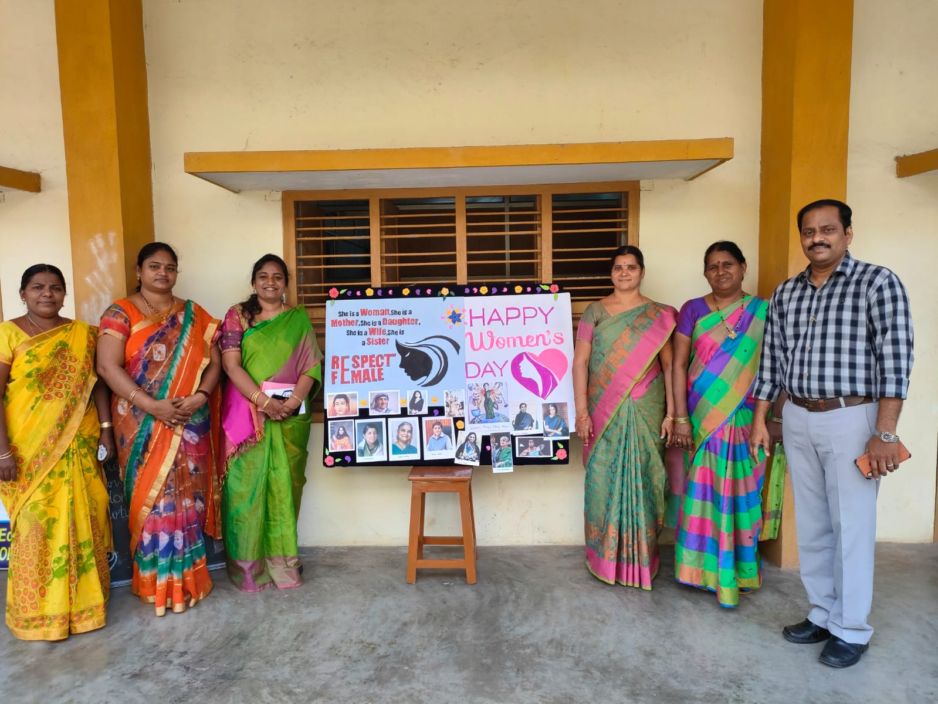
28th February, 2022 National Science day is celebrated. The students of 2nd year B.Ed.’s are in Internship programme. So, Incharge of programme committee, Mrs. Ch.R.Devi informed the students to conduct Science day in their respective schools. So they arranged Quiz, Seminars and also Science exhibitions and different Varity of activities related to Science and Technology to bring awareness towards importance of Science.
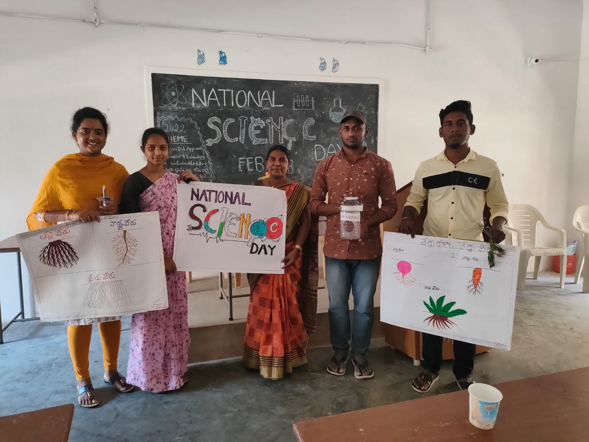
Activities in the month of March, 2022
March 8th: Women’s day celebrated to honour the women and bring awareness among women about her rights and duties along with Degree College.
delivered a speech explained about the laws and apps which helps in their troubles.
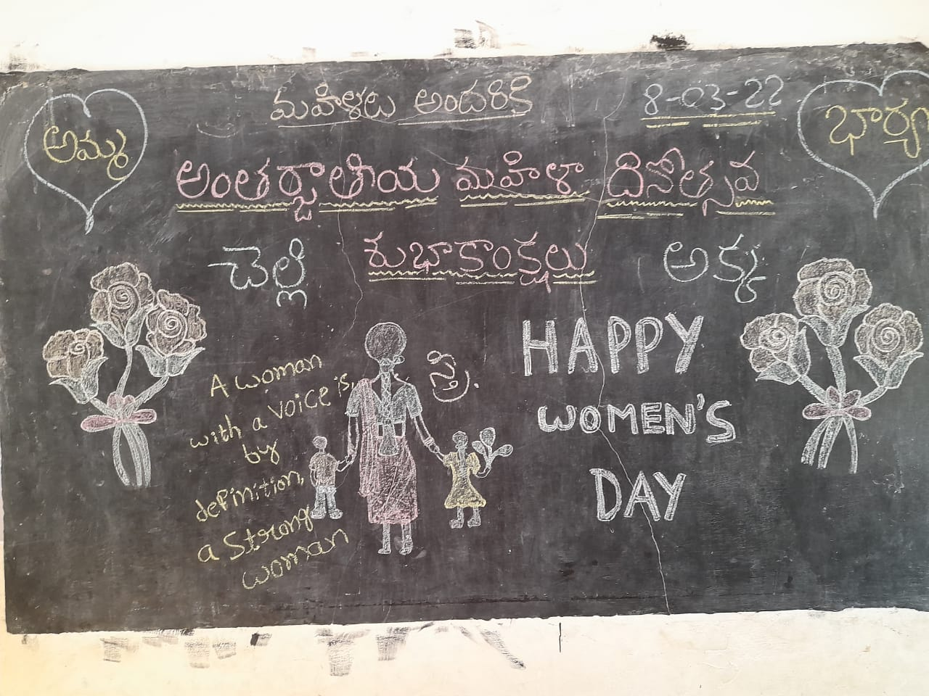
March 9th – Staff attended for Moderation Board at University to submit records for 2nd semester.
March 30th & 31st - Mid examinations were conducted for 3rd Semester students.
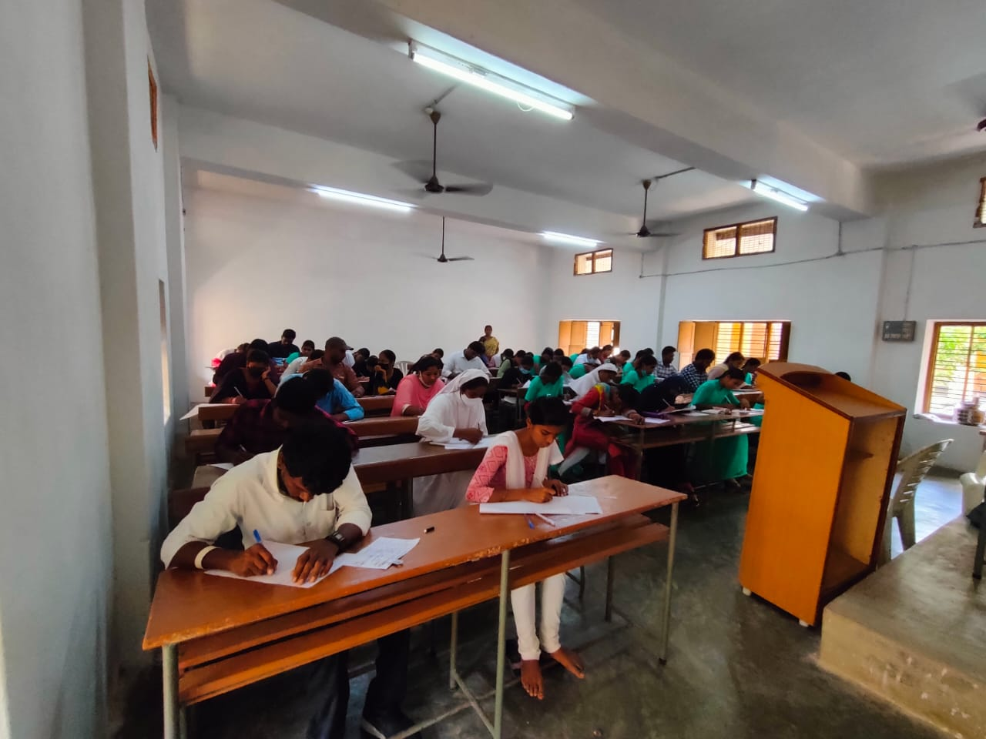
As per the guidelines of AKNU
March 31st admissions are closed for the batch 2021-22. Total number of students 35 are admitted for this Academic year.
Activities in the month of April, 2022
- April 7th: Our Planet, our Health
World Health Day was celebrated in the seminar mode. World Health Day is celebrated every year on 7th April to commemorate the anniversary of the founding of the World Health Organization (WHO) in 1948.
Each year for this date, a theme is choren that highlights an area of priority concern for WHO. In the face of the current pandemic, a polluted planet, and an increasing incidence of diseases, the theme for World Health Day is “our Planet, our Health”.
World Health Day was celebrated in seminar mode by B.Ed. students and 27th & 28th April ,Health camp conducted by U.G. & P.G. Colleges.

Activities in the month of May, 2022
- 3rd, 4th, 5th - Conducted II - Mid Examinations for II – Semester students of 2021-2023 Batch.
- 15th May to 16th June – AKNU declared Summer Vacation for the II – Semester students of 2021-2023 batch, and II – Semester students of 2020-2022 Batch 30th May to 6th June – Vacation for staff

Activities in the month of June, 2022
- College re-opens on 3rd June for the faculty for Sri G.V.R. Institute of Education.
- One week Faculty Development Programme (FDP-2022) organized by IQAC, SYNC Paradigms of OUT COME – BASED teaching and learning from 4th June to 7th June.
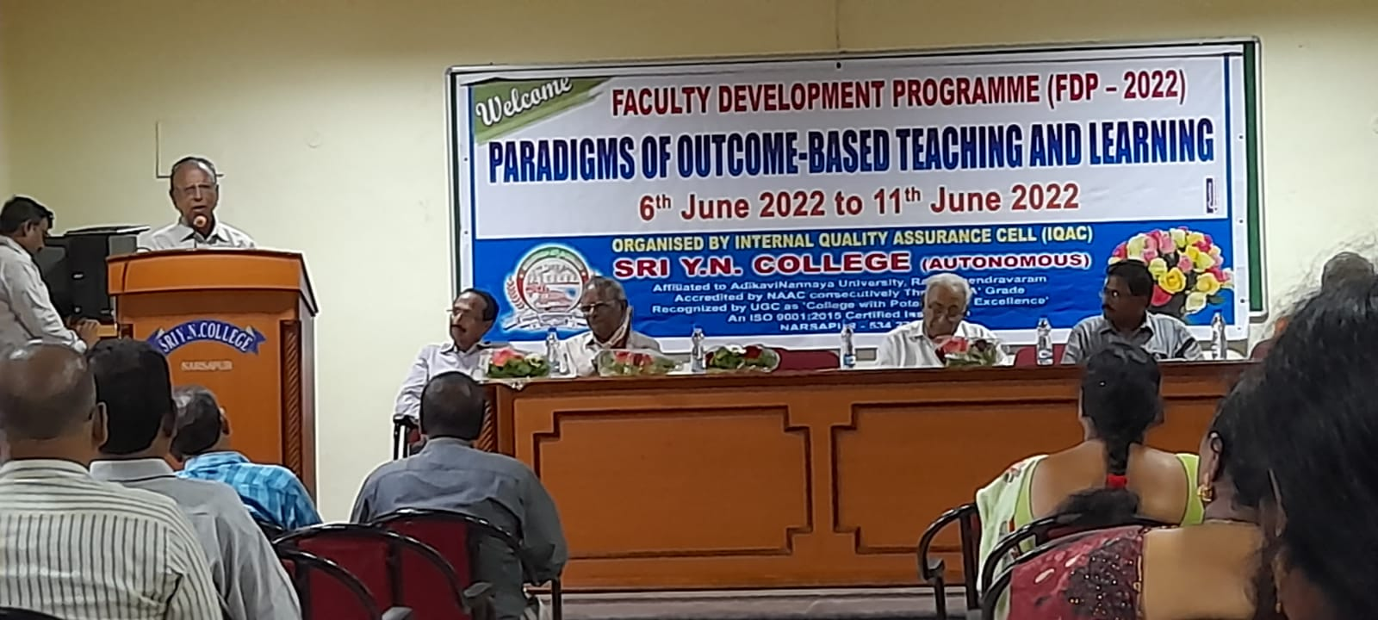
- On 7th June – Two of the faculty members selected as resource persons for FDP – 2022 Mrs. P. Krupalina, Lecturer in English, Methodology has taken a topic for FDP is “Engaging Adolescents and making thinking Visible”.
Mrs. G. Radha, Lecturer in Social Methodology has taken a topic for F.D.P. is “Strategies to enhance the teaching learning process”.
- I – Semester Examinations conducted for the students of 2021-2023 Batch from 8th to 14th June.
- International Yoga day was observed on 21st June.
Conducted T.L.M. – Workshop for II & IV Semester students from 9.30 am to 12.30 pm and 1.00 pm to 4 p.m. conducted on 23rd to 24th June.
Activities in the month of July, 2022
- Mid Examinations Conducted for IV Semester students in college form 5th to 7th July.
- II - Semester 2021 - 23 Batch students attend School Observation Programme in various schools between 8th July to 23rd July.
Activities in the month of August, 2022
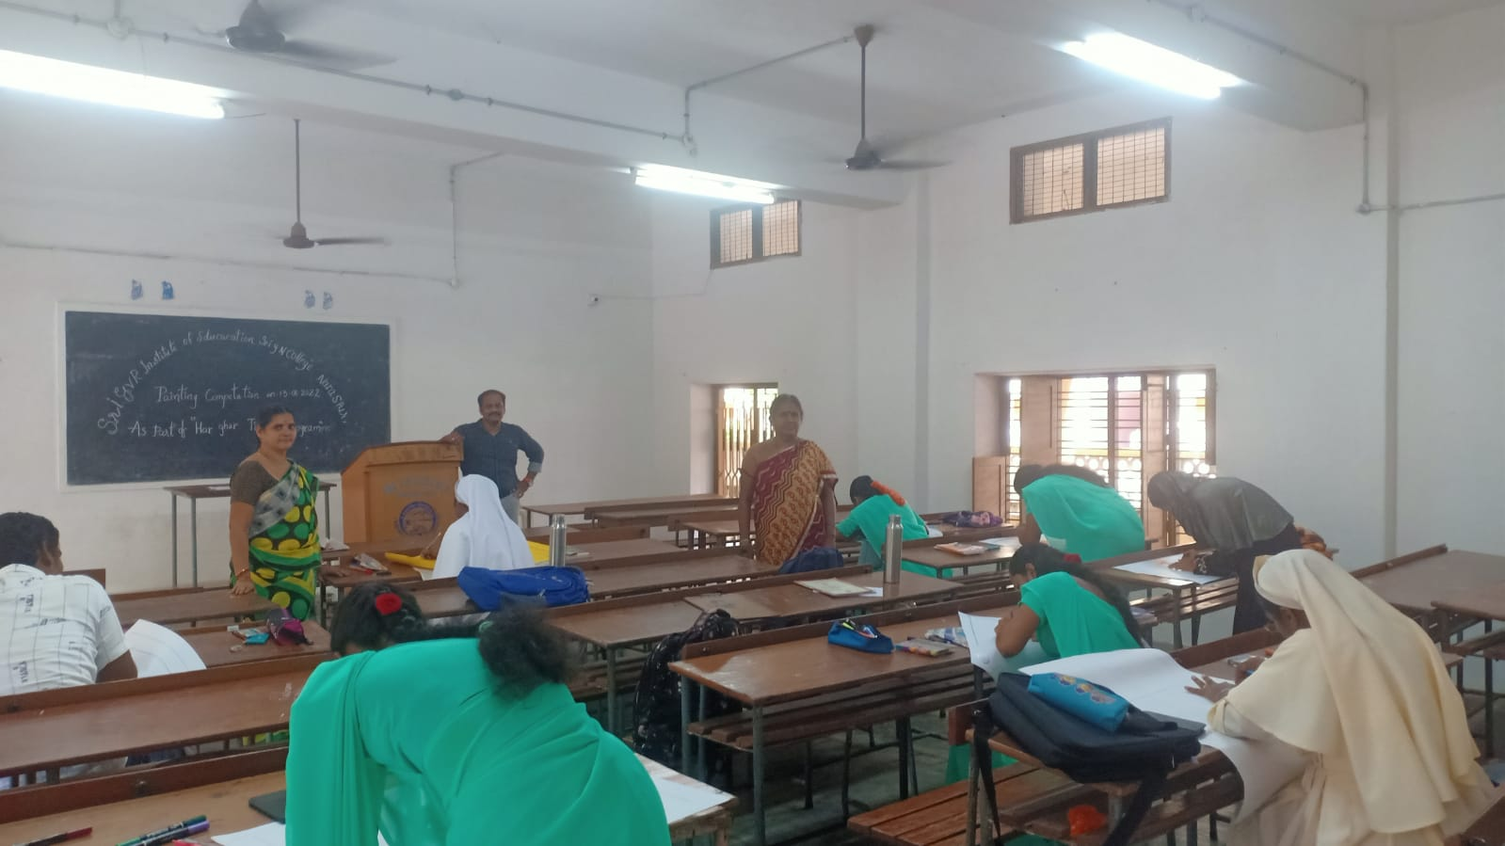
- 1st August – On the occasion of 76th Independence Day Harghar Tiranga progamme was conducted, II - Semester students participated in Drawing Competitions V. Anusha of Physical Science Methodology got 1st prize and Sk. Ayesha of Biological Sciences Methodology got 2nd prize on the part of Harghar Tiranga Programme Competitions.
- Students of IV – Semester 2020-21 Batch went to Internship programme in various schools between 8th July to 6th August.

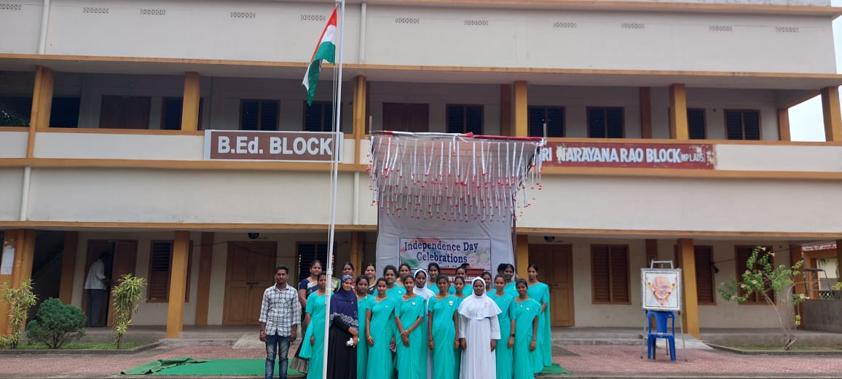
- 76th Independence Day celebrations were held in our college permises, on 15th August. Our students presented patriatic songs and delivered speeches related to Independence Day.
- Last date for submission of records is 18th August ,2022 for IV-Semester students.
- Verification of APHERMC work was done on 18th August.
- Corrections of final practical lesson plan record was done for IV-Semester students.
- IV – Semester Examination conducted by University between 26th to 28th August.
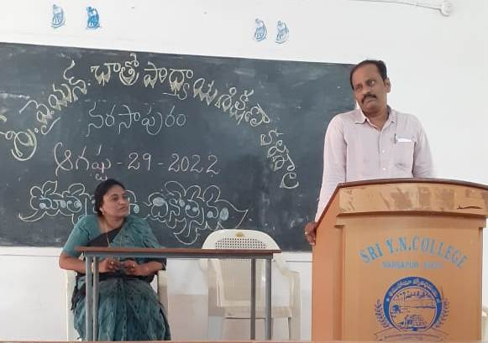
- Matru Bhash Dinotsavam was observed and celebrated in the college in the form of Seminar on the topic Importance of mother tongue on 29th August.

Activities in the month of September, 2022
- MID – II – Examinations were conducted for II Semester students on 2nd & 3rd September.
- On the occasion of teachers day seminar was arranged for the II-Semester students. In this connection Dr. Sarvepalli Radha Krishnan photo was garlanded by the Sri G.V.R. Institute of Education – Sri Y.N. College faculty followed by speeches by faculty and student teachers on 5th September.
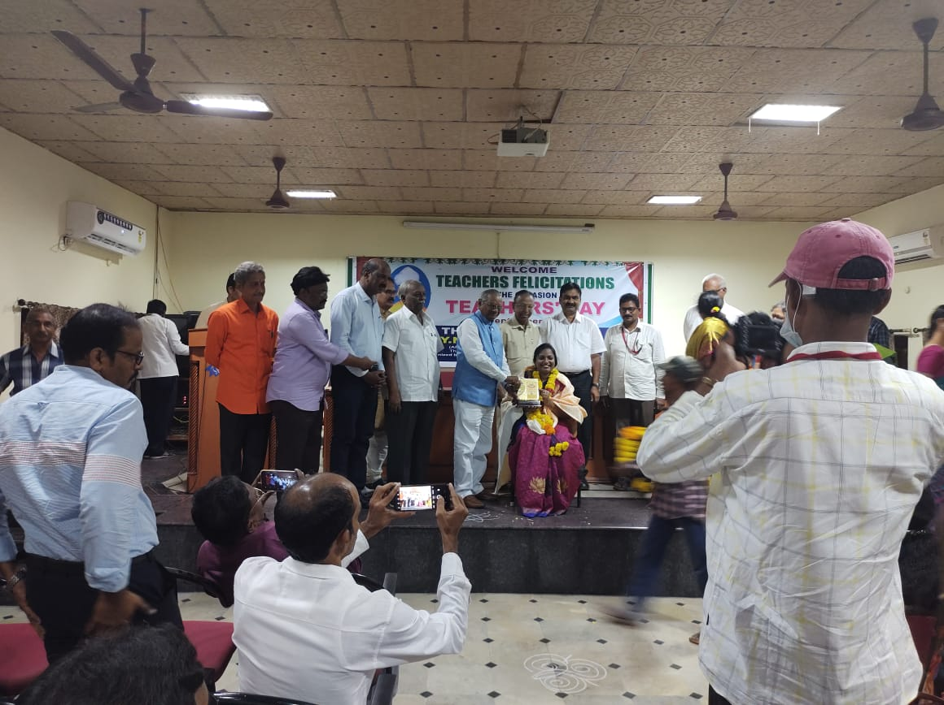
- On the occasion of Teachers day , Dr. P. Santhi – Principal of Sri G.V.R. Institute of Education – Sri Y.N. College was felicitated by Sri Y.N. College Management.

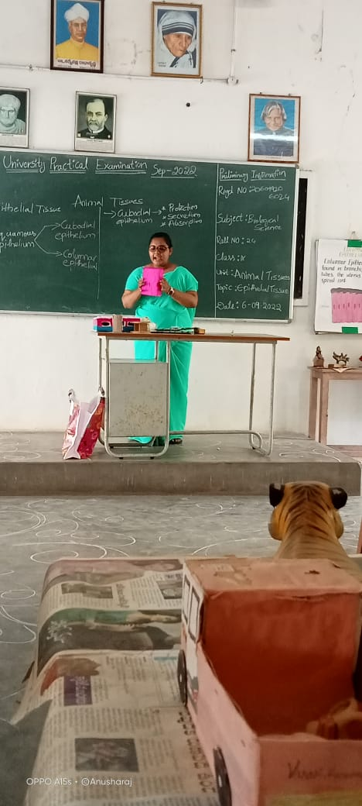

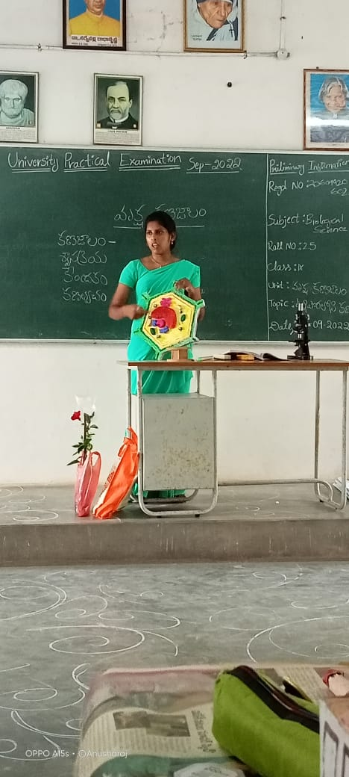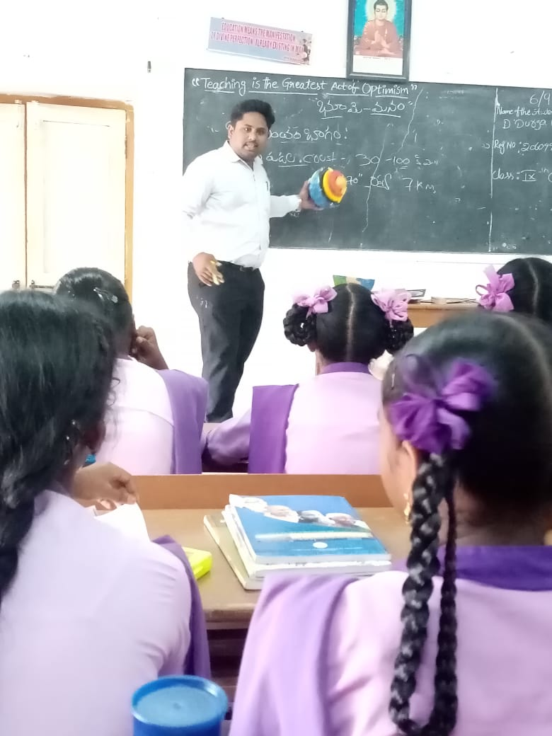
- Final Practical’s for IV – Semester students 2020-2022 Batch held in the college from 6th to 8th September.
- On Sports day ,games were arranged by Sri Y.N. College. Sri G.V.R. Institute of Education – Sri Y.N. College II – Semester participated in Games Competition on 13th & 14th September.
- Lab Stock was verified by concerned methodology faculty on 17th September
- Two of the Faculties attended for 1st Semester paper valuation at AKNU – Rajamahendravaram on 21st to 23rd September.
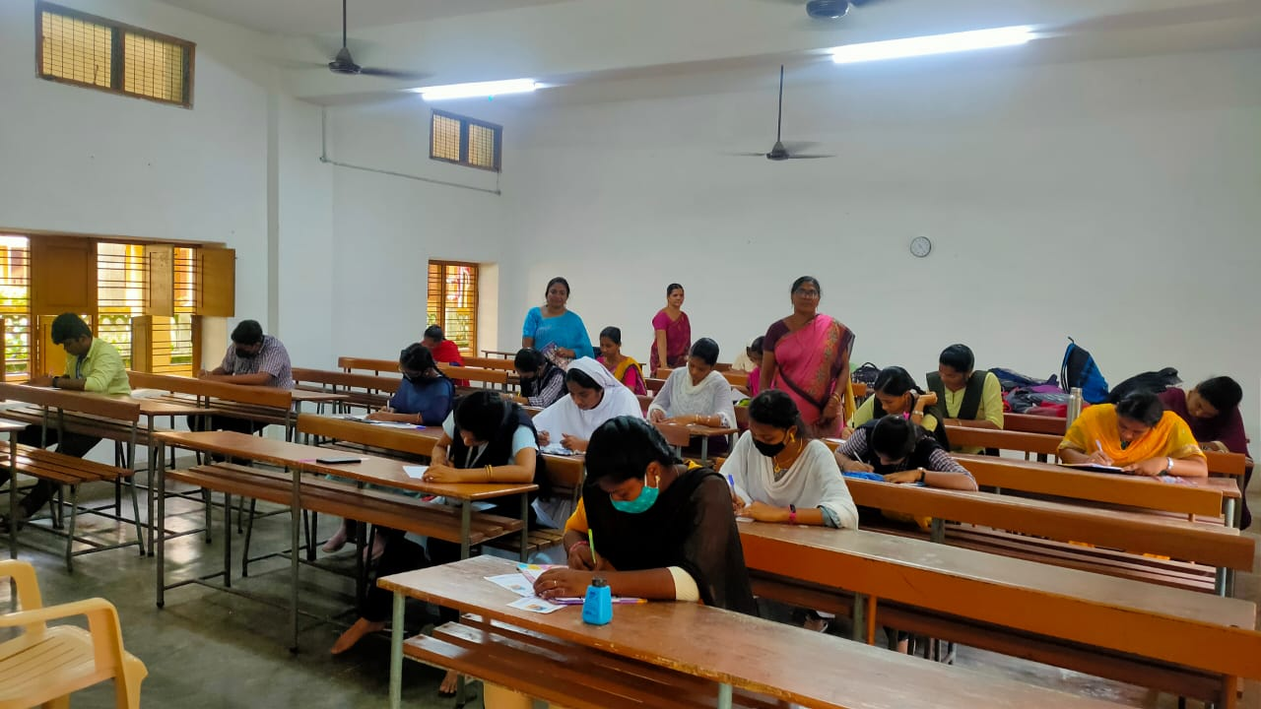
- Students of II – Semester participated in Literary and Cultural Competitions on the occasion of 153rd Gandhi Jayanthi Celebrations conducted by Gandhiyan Study Center, Sri Y.N. College on 22nd & 23rd September.
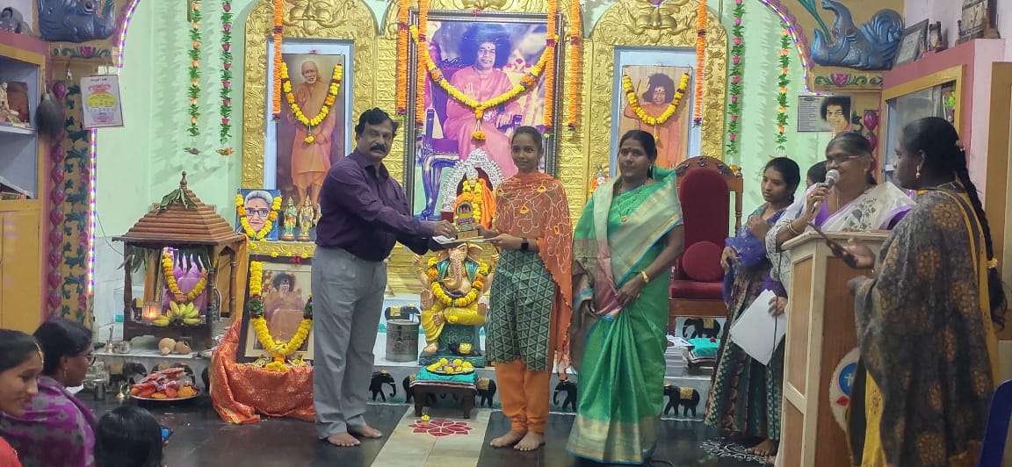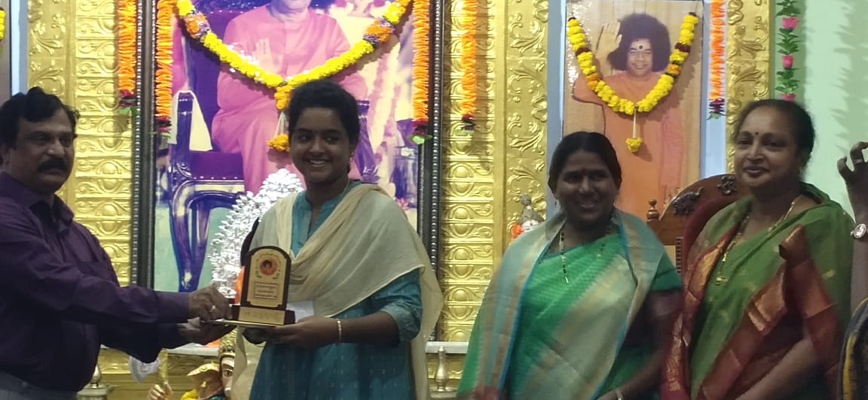
- Our students participated Sri Satya Sai Rastriyan Eassy Writing Competitions and M. Aiswarya Lakshmi Mathematics and English Methodology of got 3rd Prize in Degree level on 22nd September.
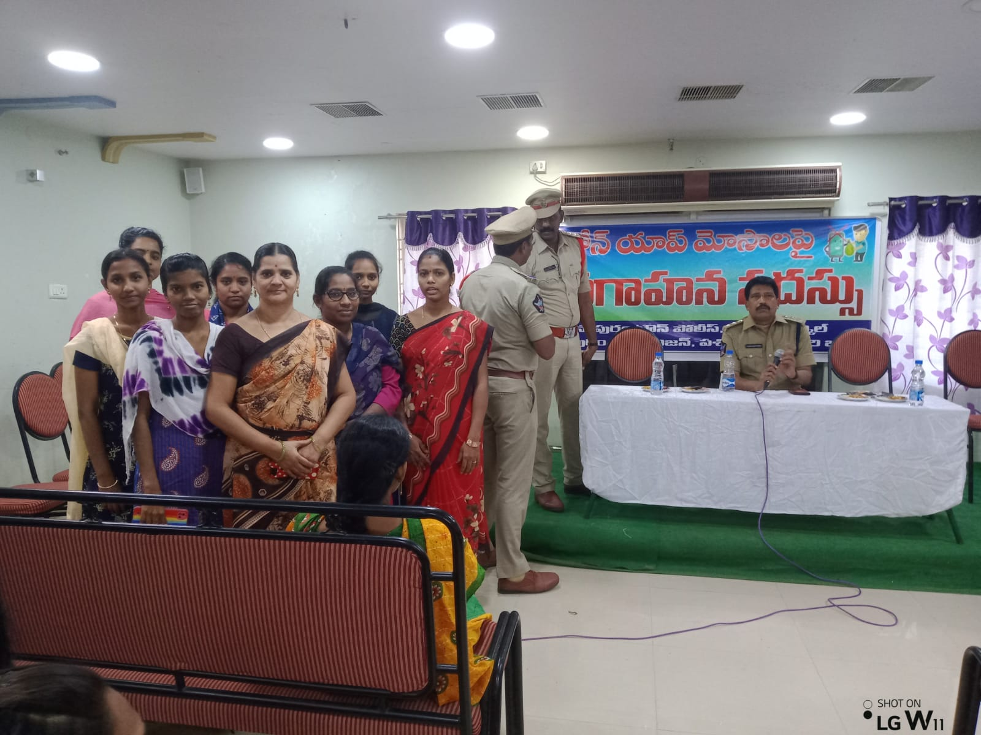
- II Semester students attended Loan App awareness programme at Vasavi Kalyan Mandapam on 23rd September.
- Staff attended for IV – Semester moderation board at AKNU – Rajanagram, Rajamahendravarm on 29th September.

Activities in the month of October, 2022
- Dussara Vacations declared by AKNU from 30th September to 7th October.
- College re-opening day after Dussara Vacations is on 10th October.
- Revision Classes conducted for II Semester students between 10th to 17th and also record completion and verification of records done by the concerned faculty.
- Pre final Examinations conducted for II Semester students by college from 18th to 21st October.
- II Semester Final Examinations for students of 2021-2023 Batch conducted by University at Aditya Degree College, Bhimavaram as examinations Ceter from 28th to 31st October.
- Tentative plan and Time tables for III Semester were given to the staff in staff meeting by Principal on 30th October.

Activities in the month of November, 2022
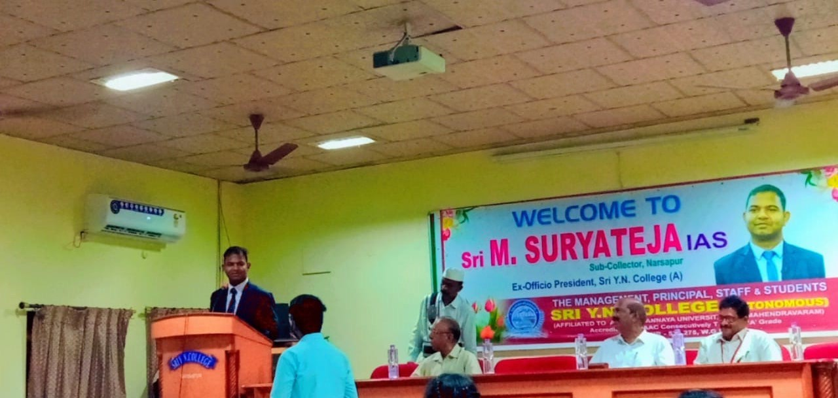
- Interaction with students by New R.D.O. of Narsapur Surya Teja, I.A.S. He is a good motivational speaker. He shared his experiences in his IAS preparation and the incidents and situations which motivated him to become I.A.S on 4th November.
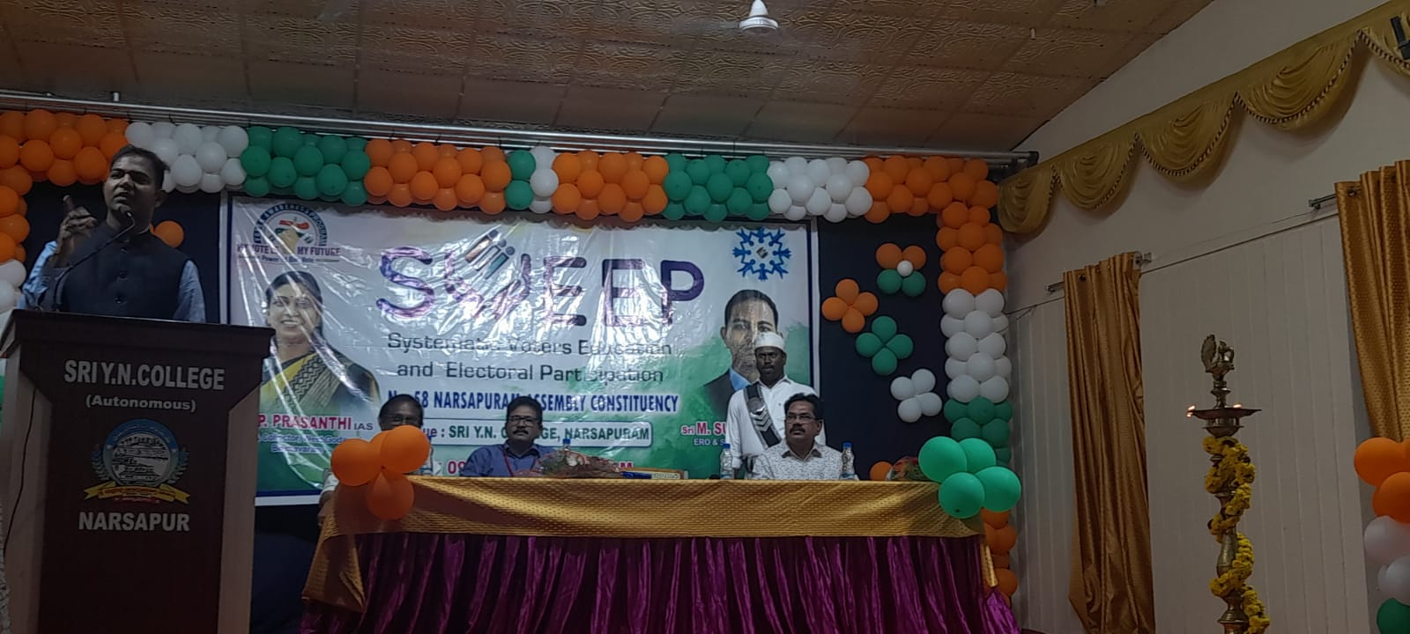
- College Management arranged voter’s awareness programme to the students of Sri Y.N. College. New Narsapur R.D.O. Surya Teja garu delivered a speech on the need and importance of vote on 4th November.

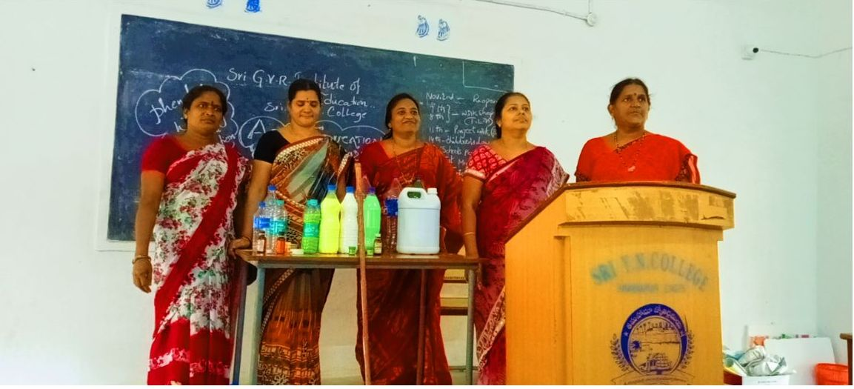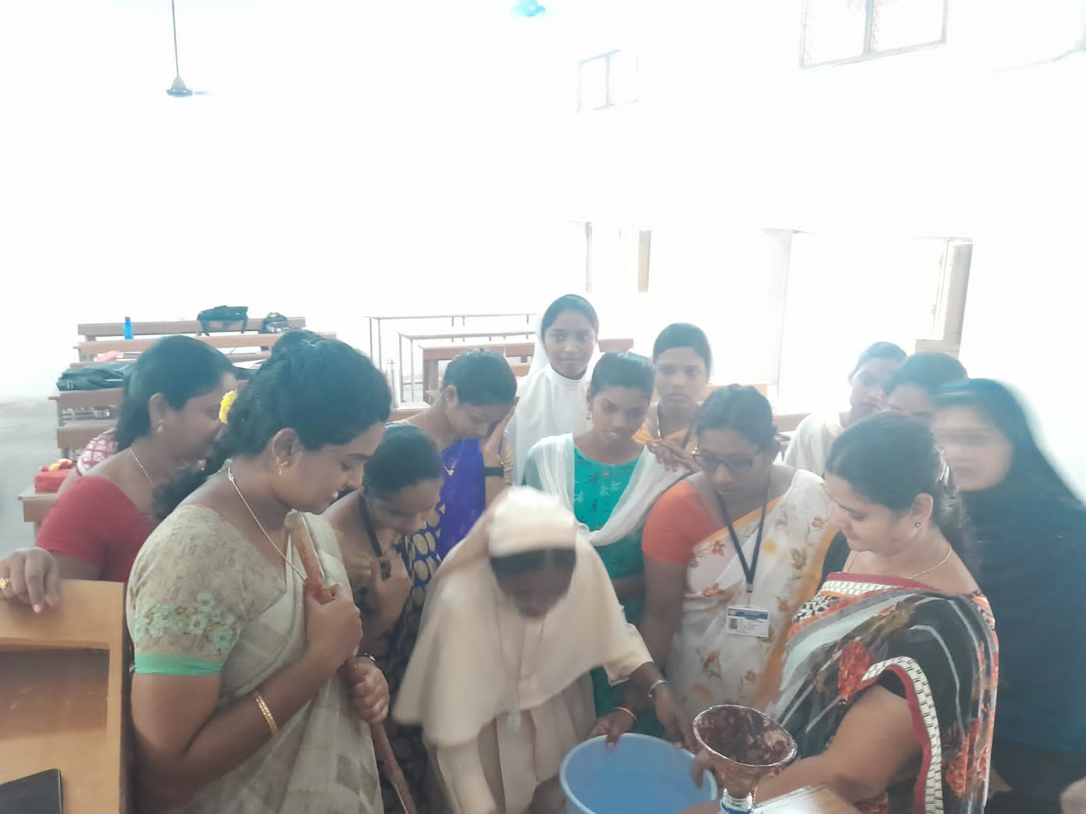
- Demonstration on preparation of Phenol, Liquid washing detergent by Principal Dr. P. Santhi and Art Education Lecturer G. Radha in III-Semester students class room on 10th November.
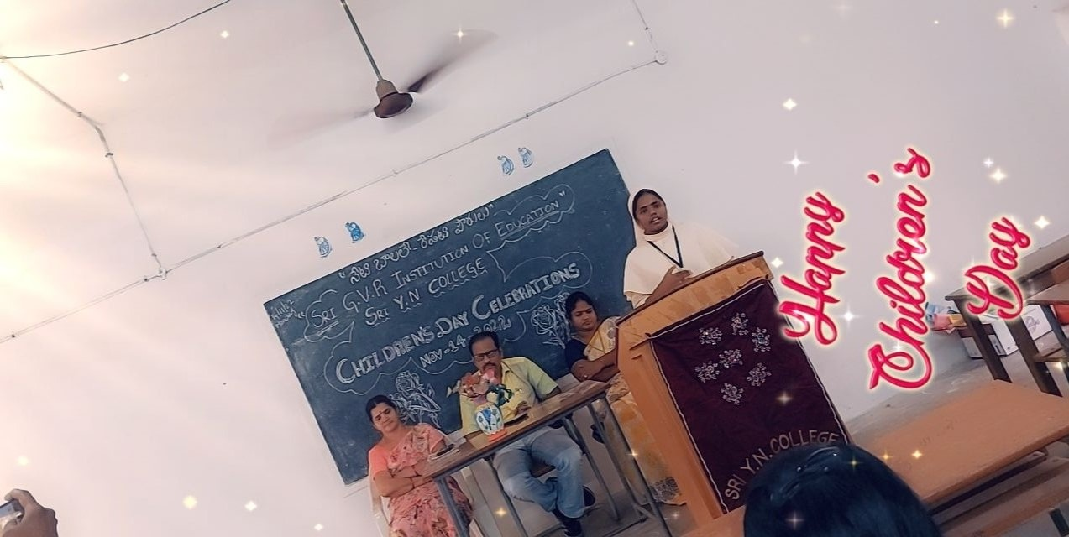
- Children’s day was celebrated in the college in which both staff and students were participated. While a role of anchoring was done by Rajesh, speeches were given by Jyothi and other few students. Finally it was ended with the speeches of Vice-Principal M.K.R. Krishna Rao garu and Smt. G. Radha. The whole programme was revolved around one only one thing i.e. How to make the children to give more importance to values and in what way one should be groomed into a good persons good citizens of future India on 14th November.
- Mid Examinations were conducted for III-Semester students on 15th and 16th November.
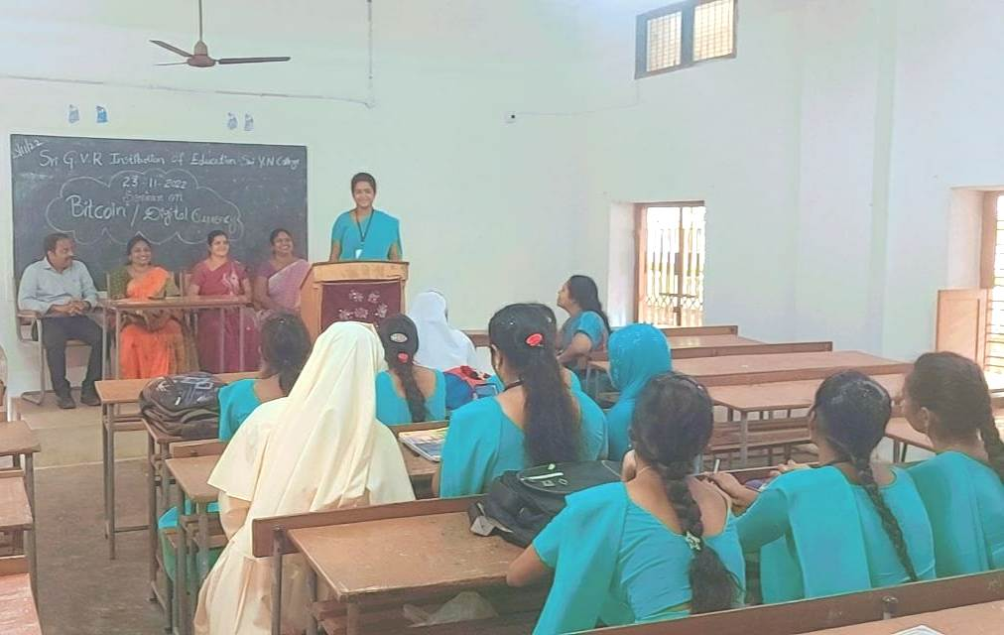
- Seminar conducted on Bit Coin and Digital Currency to get awareness among the students on 23rd November.
- On the occasion of Constitutional day mass reading of “Preamble of the constitution” was done by the students at 11a.m. on 26th November by the order of AKNU and all the participants received digital certificates.

Activities in the month of December, 2022
- All staff members attended for II-Semester Moderation Board at AKNU – Rajamahendravaram on 10th December, 2022.
- All staff members were busy in Academic Calendar preparation as a part and parcel of academic work throughout the December month calendar will be officially launched on 1st January, 2023.
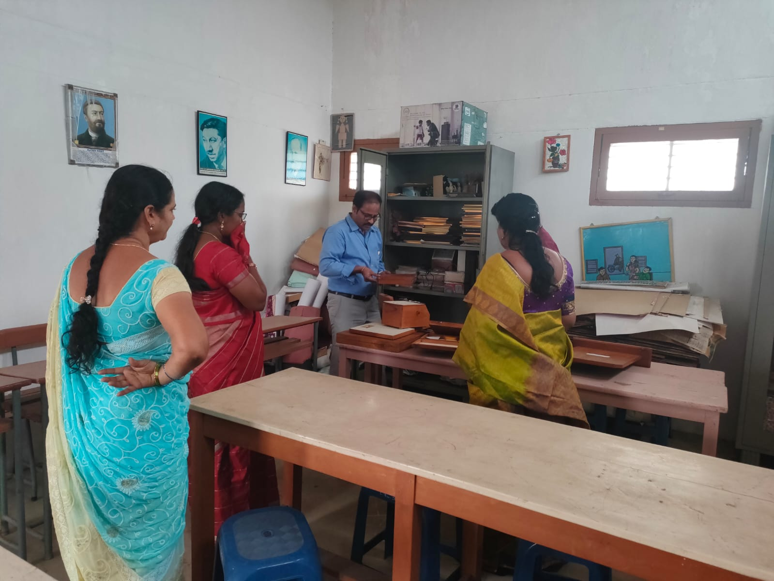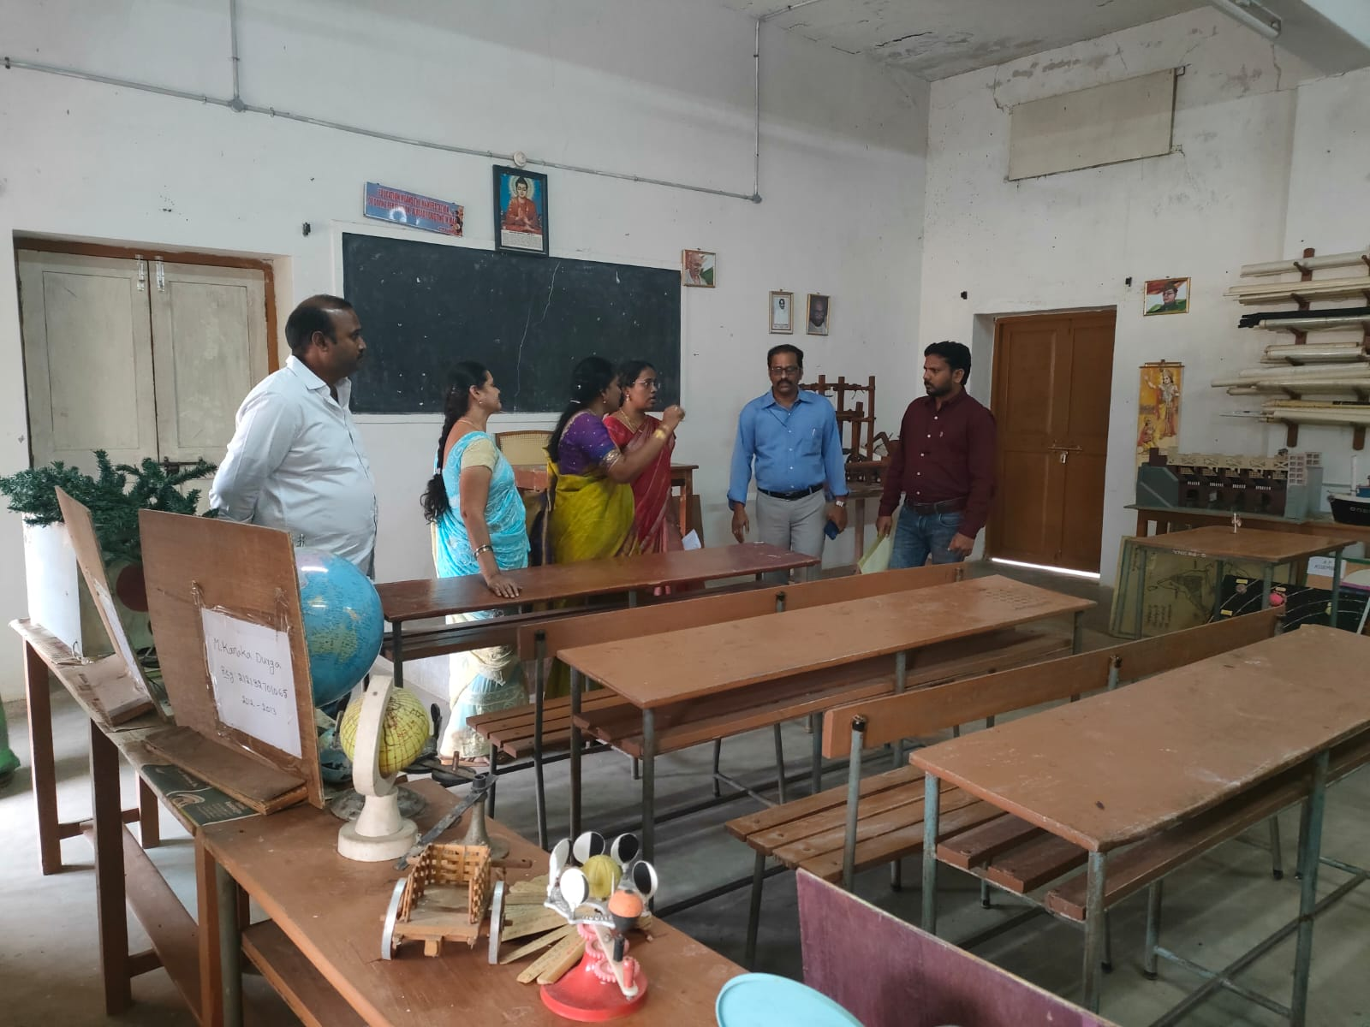
- On 21st December, 2022 prior intimation “Fact Finding Committee inspected B.Ed. Colleges Affiliation and Ratifications allotted by the AKNU. In this process on 21st Sri G.V.R. Institute of Education – Sri Y.N. College was visited by Three men committee (Dr. Kalyani - Dept. of Zoology, Dr. Dora – Dept. of Education, Dr. Phaneedra – Dept. of Physical Education) checked all the class rooms laboratories infrastructure and all the documents concerned to the college according to the APSCHE norms.
- III-Semester (2021-2023 Batch) students attended college to give the report about their internship programme about the completion of record work to their concern Methodology Lectures on 22nd and 23rd December.
- III-Semester students sowed Fenu greek seeds in the form of “Happy New Year & Pongal 2023” on the occasion of New Year 2023.
- I am glad to say that our college took a step forwarded and prepared a Calendar on our college name Sri G.V.R. Institute of Education – Sri Y.N. College. Calendar is equipped with Academic schedules of B.Ed. four semesters course and spectacular view of Sri Y.N. College pictures.

